

Derivatives

Version 1.0


Cognizant Technology Solutions US Corporation
500, Glenpointe Center West
Teaneck, NJ 07666

www.cognizant.com

1 Introductory concepts 4
1.1 Definition of Derivatives 4
1.2 Basic types of Derivatives 4
1.3 Differences between derivatives traded on the OTC and on exchanges 4
1.4 What is an option ? 5
1.5 Why use options? 6
1.6 What is a forward contract ? 6
1.7 What is a futures contract ? 6
1.8 Differences between forward and futures contracts 7
1.9 Margins 7
1.10 Daily settlement and marking to market 7
1.11 Three types of margins 7
1.12 SPAN margining system 8
1.13 The role of the clearinghouse in collecting margins 8
1.14 Three ways to close out a futures position 8
1.15 Open Interest 9
1.16 The basis and spreads 9
1.17 Intra-commodity spread 10
1.18 Inter-commodity spread 10
1.19 The Crack spread 10
1.20 The Crush spread 10
2 Futures 10
2.1 Futures and options on commodities and equities – products traded internationally 10
2.2 Commodities and Equity Indices 10
2.3 Futures / Options on Commodity / Equity Index 11
2.4 Futures trading strategies 11
2.5 Butterfly spreads using futures 12
2.6 Futures hedging strategies 13
2.7 Portfolio Insurance 14
2.8 Which maturity to trade? 14
2.9 Hedging notes 15
2.10 Notes for outright trading 15
2.11 Arbitrage 15
2.12 Program Trading and Index Arbitrage 16
2.13 Pricing 16
2.14 Convergence (on settlement) 18
2.15 Why is the farther contract more volatile? 18
2.16 Exchange for Physicals 18
3 Options 19
3.1 Options basic concepts 19
3.2 How to close out an options position: 21
3.3 Open interest 21
3.4 Margins and SPAN 24
3.5 Trading options (bullish / bearish strategies) 24
3.6 Payoff diagrams 24
3.7 Hedging with options 29
3.8 Factors affecting option prices 33
3.9 Option pricing principles 37
3.10 Option pricing model 45
3.11 Put-Call Parity 49
3.12 Implied Volatility 53
3.13 Risk Management 53
3.14 Delta hedging. 55
4 Credit derivatives 57
4.1 Conceptual aspects / definitions 57
4.2 Types of credit derivatives 60
5 Weather derivatives 63
5.1 Weather products on Chicago Climate Exchange (CCX) 63
5.2 Weather products on Chicago Mercantile Exchange (CME) 63
5.3 Earth Satellite Corporation: The Data Source: 66
5.4 General 67
6 Insurance derivatives 68
6.1 Insurance Derivatives products 68
6.2 Uses of Insurance Derivatives 69
7 Fixed income derivatives 70
7.1 Bond yield calculations 70
7.2 Duration 71
7.3 Convexity 72
7.4 Immunization 73
7.5 Mortgage backed securities 73
7.6 Convertible bonds 75
7.7 Bonds with embedded options 76
7.8 Forward pricing of bonds 77
7.9 Bond futures 78
7.10 Bond options 79
7.11 Bond options on futures 79
7.12 Duration of bond futures 80
7.13 Interest rate swaps 80
7.14 Exotic swaps 83
7.15 Caps, floors, collars 84
7.16 OTC interest rate options 84
APPENDIX: BLACK SCHOLES PRICING EXAMPLES
- Introductory concepts
  - Definition of Derivatives
The definition of derivatives is given below.
A financial or commodity contract, which derives its value (or price) from the value (or price) of an underlying asset
E.g. the price of an option on a particular stock is derived from the price of the stock.

Why derivatives? Why people trade in the derivatives rather than the underlying?
The main uses of derivatives are for hedging, speculation and arbitrage.
Hedging – This is the main use of derivatives and results in better risk management. The main aspects of hedging are described in later sections.
Speculation – This is described in later sections. The main reason why speculation with derivatives is different from speculation with the underlying is because of the leverage factor. In derivatives, one just needs to pay a small margin and can speculate and take large positions. This leverage factor is also described in a later section.
Arbitrage – Arbitrage is the process of locking in risk less profits on a transaction. This is described in a later section.

  - Basic types of Derivatives
The basic types of derivatives are as follows.
- Options
- Futures (or Forwards)
- Swaps
Descriptions of the above types of derivatives are given in the following sections.

  - Differences between derivatives traded on the OTC and on exchanges

- On the OTC:
Trades are made “over the counter” (i.e. by telephone)
Tailor – made transactions (no standardized contract structure exists on the OTC).
Usually these contracts are not actively traded (once a deal is done the trader keeps the position on his books till maturity).

- On the exchange:
Trades are made on the floor of the exchange or by computerized trading systems linked to the exchange.
Standardized contract structure.
Usually these contracts are actively traded (trader can close out his position if he wants – need not hold the position till maturity).

  - What is an option?
Options are of two types, call and put option.
A call option gives the buyer the right, but not the obligation, to buy the underlying asset at a predetermined price (strike price, or exercise price) on or before the maturity date (or expiration).
In order to buy the option the buyer pays to the writer (or seller) the option premium (or option price).
If the option is an American option it may be exercised anytime on or before maturity.
If the option is an European option it can only be exercised on the maturity date.
Example of call option:
- Call option price: $2, Underlying: IBM, Maturity: 3 months, Strike: $300
- Type of option: European
- The call buyer will pay the call writer (or seller) $2 for buying the option.
- Since the option is European it can only be exercised on the maturity date, not before.
- On maturity if the price of the underlying (in this case IBM) is greater than the strike price, the option will be exercised, otherwise it will expire worthless.
- For instance, if the IBM price is $310 on the maturity date, the buyer of the option will pay $300 (the strike price) to the writer of the option and receive one share of IBM.
- If this IBM share is then sold at a price of $310, a profit of $10 will be made.
A put option gives the buyer of the option the right but not the obligation to sell the underlying asset at a predetermined price (strike price or exercise price) on or before the maturity date (or expiration).
In order to buy the option, the buyer pays the writer (or seller) the option premium (or option price).
If the option is an American option it may be exercised anytime before maturity.
If the option is a European option it can only be exercised on the maturity date.
Example of put option:
- Put option price: $1.5, Underlying: IBM, Maturity: 3 months, Strike: $300.
- Type of option: European.
- The put buyer will pay the put writer $1.5 for buying the option.
- Since the option is European it can only be exercised on the maturity date, not before.
- On the maturity date, if the price of the underlying (in this case IBM) is less than the strike price, the option will be exercised, otherwise it will expire worthless.
- For instance, if the IBM price is $290 on the maturity date, the put option buyer will buy one share of IBM for $290 and exercise the option so as to be able to deliver to the put writer, one share of IBM and receive in return the strike price ($300). This will result in a profit of $10.
  - Why use options?
Options are non-linear derivatives (see later section for description). Thus, you pay a small amount (similar to an insurance premium) and get a big risk cover in case prices move adversely. This is also linked to the leverage effect and by paying a small amount one can speculate actively without taking on any risk. If you buy an option, the risk is limited to the option premium paid, which you might loose if the option expires worthless and is not exercised. Writing options is, however, a risky proposition and this risk is examined in later sections. The risk-return profile of options is different from linear derivatives like futures (described in later sections). Thus one may look upon linear derivatives (like futures) and non-linear derivatives (like options) as substitutes for each other. In certain situations, one may prefer to use options and in certain other situations one may prefer to use futures – it all depends on the trader’s analysis and the risk-return profiles of different trading strategies.
  - What is a forward contract?
The definition of a forward contract is given below.
A transaction to buy or sell an asset at a pre-specified price and at a pre-specified date in the future is called a forward contract.
E.g. the spot price of crude oil is $14 per barrel; the 3-month forward price is $15 per barrel.
Persons entering into a 3-month forward contract will physically exchange 1 barrel of crude oil for $15 after 3 months (even if the spot price after 3 months is different from $15).
If the spot price after 3 months is greater than $15, the long forward position (or the buyer) will make a profit.
If the spot price after 3 months is lower than $15, the short forward position will make a profit.

Concept of long and short positions:
- The act of buying is called going long.
- The act of selling is called going short.

  - What is a futures contract?
A futures contract is similar to a forward contract, because it is a transaction to buy or sell an asset at a future date at a prescribed price.
Futures contracts are traded on exchanges and have standardized contract structures, in terms of amount and maturity and other contractual features.
  - Differences between forward and futures contracts

FORWARD | FUTURES
Traded on the OTC. | Traded on exchanges.
No standardized contract structure. | Standardized contract structure.
Payment of margin not required unless contract specifies it. | Margin payments are required and are marked to market with daily settlement of profits or losses.
Usually these contracts are held to maturity. | These contracts can usually be closed out before maturity.
In a futures (or even an options) contract, one has the benefit of leverage. Essentially one pays a small amount (let us say 5% of notional value) as margin and is able to take a large position and speculate or hedge. This leads to the leverage effect, which is discussed in detail in a later section.
  - Margins
When a futures contract is entered into, margins have to be paid by both the long and the short side of the trade. The clearinghouse of the exchange collects these margins. Margins are like a security deposit. If you make profits, this is added to the margin account and you can withdraw it from your account upto a certain minimum level. If you make losses, this is adjusted in your margin account and if the balance in your margin account falls below a certain minimum level, then you have to pay additional margin.
  - Daily settlement and marking to market
Futures positions are marked to market everyday based on each day’s settlement price.
The settlement price is usually that day’s closing futures price.
The profit or loss made by each investor is adjusted daily through his/her margin account.
  - Three types of margins
- Initial margin – is paid when an investor initiates a position.
- Maintenance margin – is the minimum permissible level of the balance in the margin account.
- Variation margin – is the amount of margin to be paid when the investor receives a margin call.
How margins work:
A margin call takes place if, on account of daily settlement the balance in the margin account drops below the maintenance level.
The investor is then required to deposit variation margin in order to bring the balance in the margin account up to (at least) the initial level.
If a trader fails to respond to a margin call, then as per exchange regulations, his broker is supposed to close out his position.
On the other hand, if on account of daily settlement, the balance in the margin account exceeds the initial margin, the investor may withdraw this amount from the margin account.
E.g. suppose an initial margin of 1000 is paid and the next day on marking to market a loss of 200 is made. Then the margin account goes down to 800 and if the maintenance margin is 900 then a margin call of 100 is received and 100 of additional margin has to be deposited. On the other hand if a profit of 100 is made then keeping a 900 maintenance margin, the trader can withdraw 200 from the margin account.
  - SPAN margining system
- A system of margining for derivatives introduced and developed by the CME. Now adopted by most derivatives exchanges worldwide.
- Portfolio based margining, which analyses the risks of the entire portfolio.
- The full form is Standard Portfolio Analysis of Risk.

  - The role of the clearinghouse in collecting margins
The clearinghouse of the exchange is usually a separate company which collects margins and guarantees each trade (i.e. it takes the opposite side of each derivatives trade on the exchange). The process by which the clearinghouse collects margins is given below.
- The traders give the margins to either the clearing members or non-clearing members.
- If a non-clearing member receives margin it is passed on to his clearing member.
- The clearing members then pass on the margins to the clearinghouse.
NOTE: For broker-client relationships, the broker may specify his own margining requirements, which may be different (i.e. In addition to, the exchange’s margining requirements).
  - Three ways to close out a futures position
The three ways to close out a futures position are as follows.
- Delivery or cash settlement.
- Offsetting or reversing trade.
- Exchange for Physicals (EFP).

These three ways to close out a futures position are described below.
Physical delivery:
If a futures contract is held to maturity it is settled by physical delivery of the asset.
Most contracts settled by physical delivery permit delivery any business day of the expiration month.
Before the expiration month starts, the clearing member firms report to the clearinghouse those of their customers who hold long positions.
The short position holder, however, initiates the delivery process.
The physical delivery process, for certain contracts like US.T Bond futures:
Delivery usually takes place over three days:
Position day: Two business days before the intended delivery day, the holder of a short position who intends to make delivery informs the Clearinghouse.
Notice of intention day: The exchange selects the holder of the oldest long position to receive delivery.
Delivery day: The transaction is settled.
Thus in the expiration month, the long trader has to accept the wishes of the short trader with respect to the physical delivery conditions, specially the timing of delivery.
However, at the end of the delivery month the long trader, if he has not already received delivery, can insist on delivery.

Cash settlement:
Certain futures contracts like contracts on stock indices are settled by cash settlement on the maturity date.
The amount of cash settlement is determined by marking to market with the settlement price on maturity of the contract.
Usually the settlement price at expiration is the closing spot price of the last trading day of the contract.
Sometimes, however, for certain contracts, the settlement price at expiration is the opening spot price of the asset on the next trading day after the last trading day of the contract, this is usually done to avoid market manipulation.

Offsetting or reversing trade:
Most futures positions are closed out before maturity by entering into an offsetting or reversing trade in the same contract.

Exchange for Physicals (EFP):
This is a privately negotiated off-exchange transaction, which is later reported to the exchange.
It combines the features of physical delivery and offsetting since two parties with opposite positions privately negotiate delivery terms and inform the exchange that they would like to close out their positions.
Most physical deliveries that take place in the Oil markets are EFPs. They are also common in other commodity markets.
EFPs can also be used in cash settled markets.
  - Open Interest
Open interest for futures works in the same way as open interest for options. (see the section on options).
Open interest indicates the number of open contracts on the market at that point in time.
  - The basis and spreads
The concepts of basis and spread are given below.
Spread: Difference between two futures prices.
Basis: Spot price of an asset – (minus) futures price.
  - Intra-commodity spread
This is also called calendar spread or time spread.
It is the spread between two futures prices on the same underlying asset but with different maturities.
  - Inter-commodity spread
This is the spread between two futures prices on different underlying assets.
E.g. a very popular inter-commodity spread is the treasury/ Eurodollar spread (commonly referred to as the TED spread).
  - The Crack spread
In the petroleum markets crack spread trading is common.
The crack spread involves inter-commodity spread trading between Crude Oil futures contracts and refined products like Gasoline futures, Heating Oil futures, Kerosene futures etc.
  - The Crush spread
In the edible oil markets crush spread trading is common.
The crush spread involves inter-commodity spread trading between Soya bean futures contracts and extractions like Soya oil.

- Futures
  - Futures and options on commodities and equities – products traded internationally
The futures and options products on commodities and equities which are traded internationally are as follows.
- Futures
- Options / Options on futures
- Index futures and options
- Options on futures on the index
- Calendar spread options
- Inter-commodity spread options
- TAPOs (Traded Average Price Options)
- Cash settled products
  - Commodities and Equity Indices

Exchange | Index
CBOT | CRB Index  DJ AIG Commodity Index
CME | Goldman Sachs Commodity Index
LME | LMEX

Traded products on the indices:
Mostly – Index futures / Index options
Also – Options on futures
  - Futures / Options on Commodity / Equity Index
Description of futures and options on commodity or equity index is given below.
- It is a cash settled product.
- Usually for commodities there are agricultural and metals indices.
- Opportunity to expose oneself to many commodities through one instrument.
- Commodities indices are an asset class with risk profile different from other asset classes like equity/ debt etc.
- Provides investment diversification.

Popularity of commodities index derivatives:
- Market participants who want to trade/ hedge many commodities using one instrument
- Popular among financial market participants looking for investment diversification
  - Futures trading strategies
The various futures trading strategies are described below.
Outright long position with futures:
Eg. Buy the one-month GOLD future at Rs 5850.
If the price rises to 5890, a profit of Rs 40 is made.
If the price falls to 5800, a loss of Rs 50 is made.

Outright short position with futures:
Eg. Sell the two-month GOLD future at Rs 5900.
If the price rises to 5945, a loss of Rs 45 is made.
If the price falls to 5875, a profit of Rs 25 is made.

Implications of outright positions:
Outright positions are risky as they involve a leveraged transaction based on the direction of the market.
Eg. For buying a future whose nominal value is 1000, one may pay a margin of 50.
If the nominal loss is 10% (i.e. 100), this would indicate an actual loss of 200% if the investment in margin is considered.

Time spread or Calendar spread or intra-commodity spread:
Eg. The investor sells the two-month GOLD future at 5905.
The investor also buys the one-month GOLD future at 5860.
This position involves two futures contracts on the same underlying asset but with different maturities.

Implications of a time spread:
It is an yield enhancement strategy which is less risky than an outright trading position.
The outcome of the strategy does not directly depend on the direction of the market.
There is less risk because the strategy is hedged to a large extent.

Inter-commodity spread:
Spread between futures on two different commodities.
Eg.
Crush spread – spread between soya futures and soya oil futures or other extractions.
Crack spread – spread between crude and gasoline futures or other petroleum products.

Implications of an Inter-commodity spread:
This is a yield enhancement strategy, which is less risky than an outright trading position.
The outcome of the strategy does not directly depend on the direction of the market.
If the two underlying assets involved are highly correlated, the strategy is hedged to a large extent.
  - Butterfly spreads using futures
- It is a combination of 2 time spreads
E.g. One month, two month, three-month contracts are trading.
Go short 1 one month, long 2 two month, short 1 three month contracts.
Or, go long 1 one month, short 2 two month, long 1 three month contracts.

The leverage effect of derivatives:
If you invest 100 in a stock and it goes up to 110 or down to 90, you make or loose 10% on your investment of 100.
However in futures and derivatives there is a leverage effect.
If you buy a future at 100 by paying margin of 10, and the price goes up to 110 or down to 90, you make or loose 100% on your investment of 10.
This is the leverage effect.

  - Futures hedging strategies
The various kinds of futures hedging strategies are given below.
Short hedge:
E.g. the investor buys GOLD for Rs 5886.
The one-month GOLD future is sold for Rs 5910.
This is a hedging strategy.

Implications of a short hedge:
The futures contracts are sold and the investor already owns the underlying asset.
The hedge is more effective if the investor has a fixed time horizon after which the asset will be sold.
Otherwise the hedge has to be rebalanced periodically.

Long hedge:
E.g. the investor has to buy GOLD after 2 months.
He buys GOLD two-month futures for Rs 5924.
This is a hedging strategy – which is based on an anticipated transaction in the underlying.

Implications of a long hedge:
The futures contracts are bought in anticipation of a transaction in the underlying asset.
The hedge is more effective if the investor has a fixed time horizon after which the asset will be bought.
Otherwise the hedge has to be rebalanced periodically.

Risk minimization hedge:
Pooling of risks is done for hedging.
The whole portfolio or part of the portfolio is hedged.
The Beta of the portfolio with respect to the futures is calculated.
This Beta gives the Hedge Ratio.
Based on the Hedge Ratio futures positions are taken.
Periodically the hedge position is rebalanced.
This reduces the risk of the portfolio.

Risk Minimization example:
The value of the portfolio to be hedged is Rs 1Cr.
The Beta between the one-month GOLD future and the portfolio is .75
The hedge ratio is (Vp/Vf). (Beta)
Vp = value of portfolio;
Vf = value of futures contract.
We have to sell that many contracts in order to hedge.
  - Portfolio Insurance
This is a risk minimization strategy where a threshold limit is set.
Below the threshold limit, full hedging is resorted to.
Above the threshold limit, there is a formula to determine the partial hedging which will be resorted to.
Cross hedging:
Mismatches that make a hedge a cross hedge:
- The hedging horizon may not match the futures expiration date.
- The quantity to be hedged may not match the futures contract quantity.
- The futures contract may be available on an underlying asset, which is similar, but not exactly the same as the asset being hedged. E.g. hedging a portfolio of stocks using a stock index.
The above and other complications make hedging an imperfect science, which requires the skill and judgement of the trader as much as mathematical analysis.
  - Which maturity to trade?
In order to understand which maturity to trade, let us look at the following example.
In a normal market –
There are upward sloping prices:
E.g. GOLD futures,
One month: Rs 5,800.
Two month: Rs 5,870
Three month: Rs 5,900

If prices are expected to rise,
Then farther contracts will move the most (we shall explain later why),
In this situation what position will you take?
Answer:
You can go long either the one month or the two month or the three month future.
However, the three-month contract is expected to move the most and will give the largest profit.

What will you do if prices are expected to fall?
Answer:
You can go short either the one-month or the two-month or the three-month future.
However, the three-month contract is expected to move the most and will give the largest profit.

Liquidity risk:
Usually farther contracts are less liquid.
Hence trading large positions in the farther contracts may entail risks.
  - Hedging notes
- Try to have a hedging horizon over which to hedge and measure your hedge performance.
- Rolling over the hedge periodically is a must.
- There will be liquidity risk while rolling over the hedge.
- Be careful of hedge trades in the delivery period for delivery based futures contracts – it is best to rollover or square up before delivery period begins.
  - Notes for outright trading
- Put stop-loss limits.
- Take small positions, not large positions.
- Do not keep open positions for a long time.
- Try to take positions in liquid contracts so that squaring up is easy if required.
- Try to square up before the end of the day in order to avoid large price jumps from one day to the next.
  - Arbitrage
Arbitrage is a trading strategy which provides risk-less or sure profits usually with net zero initial investment.

If the futures price is higher than fair value how will you arbitrage?
Sell futures and buy cash.
In order to buy cash, borrow money.
Even after paying interest you will lock in an arbitrage profit since the futures price is higher than fair value.
NOTE: There will be other carrying charges like storage and insurance, which will need to be factored into the fair value.

If the futures price is lower than fair value how will you arbitrage?
Buy futures and short-sell cash.
This is reverse arbitrage.
Lend the proceeds of short sale in the market.
The interest you receive will be more than the money required to cover the futures price since this price is lower than fair value.
This will give you an arbitrage profit.

Market imperfections:
If short selling is restricted or not possible, there will be restrictions on reverse arbitrage.
This means that the futures price will be allowed to go lower than fair value.
There are also different rates for borrowing and lending (Bid-Ask spread for the interest rate).

Implications of market imperfections:
Market imperfections mean that there will be a no-arbitrage bound or a price range.
Outside the price range arbitrage will be possible and will make sure prices stay within the range.
Within the range arbitrage will not be possible and market’s expectations will determine prices.

Execution risk (in arbitrage):
In any arbitrage transaction or trading strategy there will be execution risk.
Execution risk is the risk that prices change before you execute your strategy.

  - Program Trading and Index Arbitrage
Index arbitrage is usually done through trading programs.
This is called program trading.
Mostly program trading makes use of index arbitrage but other strategies like technical trading and portfolio insurance and hedging can also be done using program trading.
  - Pricing
Consider for the moment that theoretically speaking the price of a futures contract is equal to the price of an otherwise identical forward contract.
Even though there could be minor differences, we shall examine these later.
Two well-known models of futures prices are:
- Cost of carry model
- Expectations model (forward price = expected future spot price)

Cost of carry model in perfect markets:
Perfect markets means that we assume that there are no transactions costs, margins and other restrictions.
The cost of carry pricing model is given as:
F = S*(1+C)
Where,
F = the futures price.
S = the spot price.
C = the cost of carry, expressed as a fraction of the spot price.
Explanations:
Cost of carry or carrying charge = total cost necessary to carry the good forward from the present to the delivery date on the futures.
Types of carrying costs:
- Storage cost and Insurance and transportation (relevant for physical goods / commodities)
- Financing costs (i.e. the interest rate – relevant for both commodities and financial products)
- The cost of carry is also called the implied repo rate.

Concept of a full carry market:
In a full carry market, prices conform to the cost of carry model.
Since interest rates are always positive, a full carry market is always a normal market.
(In a normal market, the prices of more distant contracts are higher than the prices of nearby contracts; the reverse is called an inverted market).

Relation between a full carry market and arbitrage:
A market is above or below full carry if futures prices are above or below cost of carry prices.
If arbitrage and reverse arbitrage is easily possible (markets are close to perfect), prices will usually be at full carry.

Differences between forward and futures prices:
Reasons for possible differences in forward and futures prices on the same asset and with the same maturity:
- Daily settlement cash flows on the futures contract.
- No margins (default risk) on the forward contract.
- Differences in tax treatments.
- Differences in transactions costs.
- Focusing on the daily settlement issue we may reason that if futures prices rise first and fall later, the long trader will receive cash flows which can be invested for a longer time period.
- Thus, in the above situation the long trader will prefer to buy the futures contract and its price will be higher than the corresponding forward contract.
- The reverse will be true if prices fall first and then rise.
- However, since it is impossible to predict future price movements and since various other factors other than daily settlement, also cause differences in futures and forward prices, we rely on empirical evidence.
- Studies show that in most markets the differences between futures and forward markets are small – less than 1%.

Linear and non-linear derivatives:
Derivatives like futures are called linear derivatives since their fair price function is linear.
Derivatives like options are called non-linear derivatives since their fair price function is non-linear.
  - Convergence (on settlement)
On maturity the cash price and the futures price should converge to the same value.
What will happen if the cash price and futures price on maturity are different?

Question:
If the futures price on maturity is higher than the cash price how will you arbitrage?
Answer:
Buy cash sell futures.

Question:
If the futures price on maturity is lower than the cash price how will you arbitrage?
Answer:
Sell cash buy futures.

Convergence:
Thus in order to prevent such arbitrage opportunities most exchanges make the futures price on maturity converge with the cash price.
  - Why is the farther contract more volatile?
This is because of cost of carry pricing.
The farther contract has a larger percentage of carrying cost built into it since the time period of carry is longer. Hence for each percentage change in the spot price, the farther futures contract changes by a higher percentage than the nearby contract. Hence it is more volatile.

  - Exchange for Physicals
How to close out a futures position:
- Settlement on maturity by delivery or cash settlement.
- Offsetting position to close out before maturity.
- Exchange for physicals before maturity.

EFP Description:
It is an off-exchange transaction, which is later, reported to the exchange.
Price and terms are privately negotiated.
You take or give delivery and close out your futures position before maturity.

The EFP market:
There are market makers who give two-way quotes just for EFPs.
EFPs add to volumes and liquidity not only in futures but also in the cash market.
EFP provides traders with new trading strategies.

EFP example:
An example of an EFP is as follows.
Long position holder and short position holder negotiate an EFP.
Delivery and settlement takes place outside the exchange.
The exchange is asked to close out the long and short positions through EFP.

- Options
  - Options basic concepts
Options are of two types, call and put options.
Call Option
A call option gives the buyer the right, but not the obligation, to buy the underlying asset at a pre-determined price (strike price, or exercise price) on or before the maturity date (or expiration).
In order to buy the option the buyer pays the writer (or seller) the option premium (or option price).
If the option is an American option it may be exercised anytime on or before maturity.
If the option is a European option it can only be exercised on the maturity date.
Example of a call option:
Call option price: $2, Underlying: IBM, Maturity: 3 months, Strike: $300.
Type of option: European.
The call buyer will pay the call writer (or seller) $2 for buying the option.
Since the option is European it can only be exercised on the maturity date, not before.
On maturity if the price of the underlying (in this case IBM) is greater than the strike price, the option will be exercised, otherwise it will expire worthless.
For instance, if the IBM price is $310 on the maturity date, the buyer of the option will pay $300 (the strike price) to the writer of the option and receive one share of IBM.
If this IBM share is then sold at a price of $310, a profit of $10 will be made.

Put option:
A put option gives the buyer of the option the right but not the obligation to sell the underlying asset at a predetermined price (strike price or exercise price) on or before the maturity date (or expiration).
In order to buy the option, the buyer pays the writer (or seller) the option premium (or option price).
If the option is an American option it may be exercised anytime before maturity.
If the option is a European option it can only be exercised on the maturity date.
Example of put option:
Put option price: $1.5, Underlying: IBM, Maturity: 3 months, Strike: $300.
Type of option: European.
The put buyer will pay the put writer $1.5 for buying the option.
Since the option is European it can only be exercised on the maturity date, not before.
On the maturity date, if the price of the underlying (in this case IBM) is less than the strike price, the option will be exercised, otherwise it will expire worthless.
For instance, if the IBM price is $290 on the maturity date, the put option buyer will buy one share of IBM for $290 and exercise the option so as to be able to deliver to the put writer, one share of IBM and receive in return the strike price ($300).
This will result in a profit of $10.

Cash settlement of options:
E.g. Options on the S&P100 index traded on the CBOE.
Since for these options, the underlying asset is an index (which cannot be physically traded) these options, if exercised, are settled by cash settlement, and not by physical delivery of the underlying asset.
E.g. For a call, if on maturity the index level is 310 and the strike price is 300, the call buyer will receive $10 from the call writer.
For a put, if on maturity the index level is 290 and the strike price is 300, the put buyer will receive $10 from the put writer.

Intrinsic Value:
What is the intrinsic value (also called parity value or exercise value) of an option?
(S – E), for calls.
(E – S), for puts.
Where, S = the price of the underlying asset.
E = the strike price (or exercise price) of the option.

The concept of “in-the-money”:
When intrinsic value > 0 , the option is in-the-money.
When intrinsic value = 0 , the option is at-the-money.
When intrinsic value < 0 , the option is out-of-the-money.
If the intrinsic value is positive and large, the option is said to be “deep-in-the-money”.
If the intrinsic value is negative and large, the option is said to be “deep-out-of-the money”.

When will a call option be in the money?
Answer: When S>E.
When will a put option be in the money?
Answer: When E>S.
When will a call or a put be at the money?
Answer: When S = E.

  - How to close out an options position:
Closing out at maturity
- An option expires worthless and is not exercised – call buyer loses option premium, call writer keeps option premium.
- Option is exercised – for European options this can only happen on the maturity date, for American options this can happen anytime before maturity.

Assignment of options on exercise:
For American options – in case of exercise before maturity, assignment of buyers to sellers is done by the exchange.
The assignment is usually done on one of the following bases – first in, first out, random.
For American and European options – Exercise or non-exercise on maturity is automatic.

Closing out before maturity –
Suppose you have bought an option, which has some time left before maturity.
This means that you hold a long position in that option.
If you sell exactly the same option, the exchange will automatically consider only your net position (in this case zero).
Similarly going long in exactly the same option contract can also close out a short position.
  - Open interest
Open interest indicates the number of open option contracts on the market at that point in time.

Will closing out before maturity result in a reduction of open interest?
CASE (1): Open interest gets reduced:
Day (1) –
‘A’ buys 1 option, ‘B’ sells 1 option.
Open interest = 1 option.
‘A’ has a long position of 1 option, ‘B’ has a short position of 1 option.
Day (2) –
‘A’ sells 1 option (and closes out his position), ‘B’ buys 1 option (and closes out his position).
Open interest = 0 (Open interest gets reduced).
‘A’ has a net position of 0, ‘B’ has a net position of 0.

CASE (2): Open interest does not get reduced:
Day (1) –
‘A’ buys 1 option, ‘B’ sells 1 option.
Open interest = 1 option.
‘A’ has a long position of 1 option, ‘B’ has a short position of 1 option.
Day (2) –
‘A’ sells 1 option (and closes out his position), ‘B’ does nothing.
‘C’ buys 1 option (and takes the other side of A’s trade).
Open interest = 1 (remains the same as before)
‘A’ has a net position of 0, ‘B’ has a short position of 1 option (same as before).
‘C’ has a long position of 1 option.

Will entering into a fresh position result in a reduction or increase of open interest:
CASE (1): Open interest gets reduced:
Day (1) –
‘A’ buys 2 options, ‘B’ sells 2 options.
Open interest = 2 options.
‘A’ has a long position of 2 options, ‘B’ has a short position of 2 options.
Day (2) –
‘B’ buys 1 option, ‘A’ sells 1 option.
Open interest = 1 (open interest gets reduced)
‘A’ has a net position of 1 long, ‘B’ has a net position of 1 short.

CASE (2): Open interest increases:
Day (1) –
‘A’ buys 2 options, ‘B’ sells 2 options.
Open interest = 2 options.
‘A’ has a long position of 2 options, ‘B’ has a short position of 2 options.
Day (2) –
‘C’ buys 2 options, ‘B’ sells 1 option, ‘D’ sells 1 option.
Open interest = 4 (Open interest increases).
‘A’ has a net position of 2 long, ‘B’ has a net position of 3 short.
‘C’ has a net position of 2 long, ‘D’ has a net position of 1 short.

CASE (3): Open interest remains the same:
Day (1) –
‘A’ buys 2 options, ‘B’ sells 2 options.
Open interest = 2 options.
‘A’ has a long position of 2 options, ‘B’ has a short position of 2 options.
Day (2) –
‘C’ buys 1 option, ‘A’ sells 1 option.
Open interest = 2 (open interest remains the same).
‘A’ has a net position of 1 long, ‘B’ has a net position of 2 short, ‘C’ has a net position of 1 long.

The concept of long and short positions:
- The act of buying is called going long
- The act of selling is called going short

  - Margins and SPAN
SPAN margining system (Standard Portfolio Analysis of Risk)
Introduced and developed by CME
Now adopted by most derivatives exchanges worldwide
Portfolio based margining, which analyses the risks of the entire portfolio
  - Trading options (bullish / bearish strategies)
What is a bullish trading strategy?
A strategy based on the expectation that the underlying price will rise.

What is a bearish trading strategy?
A strategy based on the expectation that the underlying price will fall.

What is a market-neutral strategy?
Trader expects prices to remain the same or does not have a view on which way the market will move.

  - Payoff diagrams
Payoff from buying the underlying stock (going long)

Payoff / Profit
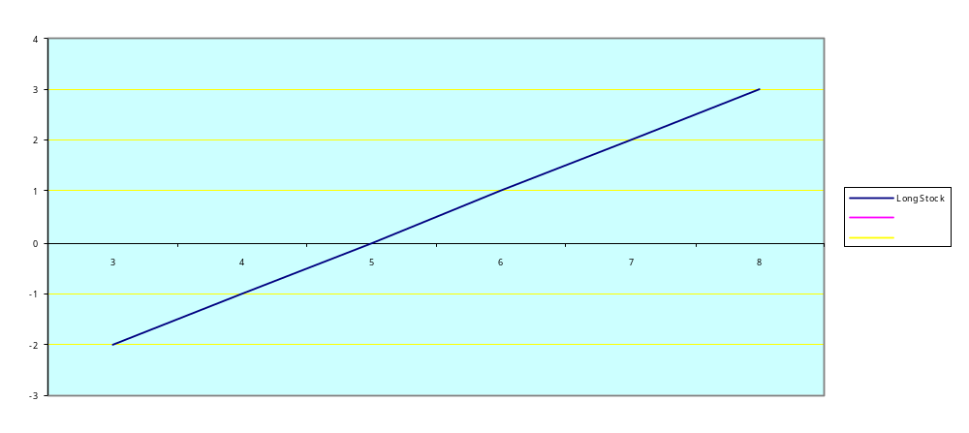
Stock Price

Payoff from short selling the underlying stock (going short)
What is short selling?
Selling what you don’t own by borrowing the asset.
At a later date you will have to buy the asset and return it to the lender.

Payoff / Profit
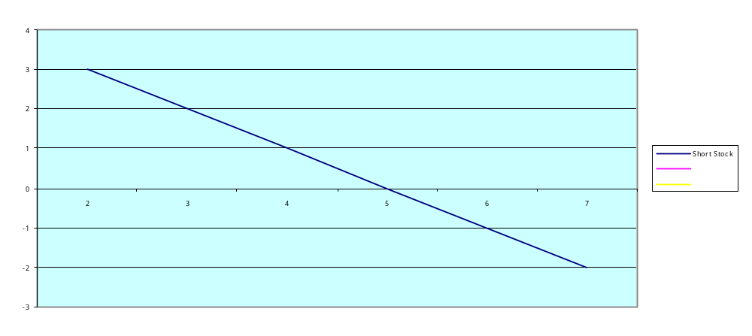
Stock Price

Payoff from buying a call

Payoff / Profit
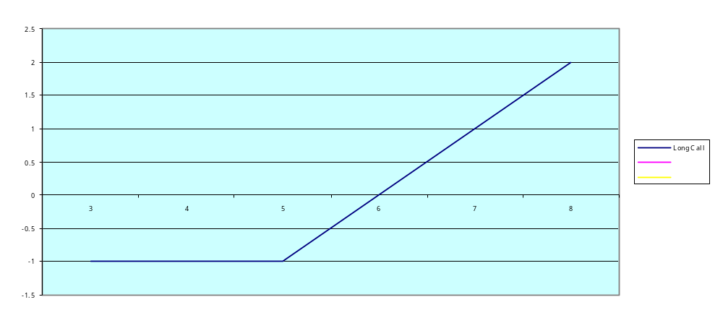
Stock Price

Payoff from writing a call
(Uncovered or naked call writing)

Payoff / Profit
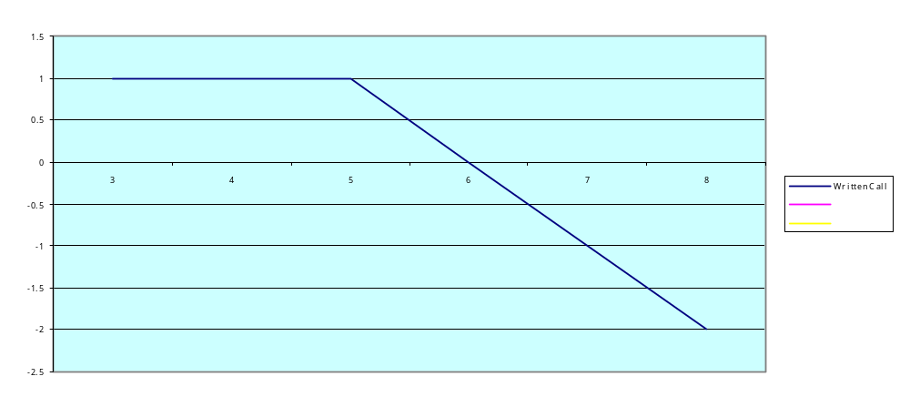

Stock Price

Fully covered call writing (buy 1 stock and write 1 call at the same time)

Payoff / Profit
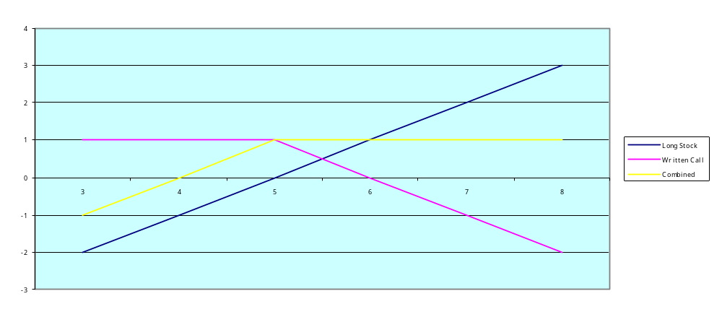
Stock Price

Payoff from buying a put

Payoff / Profit
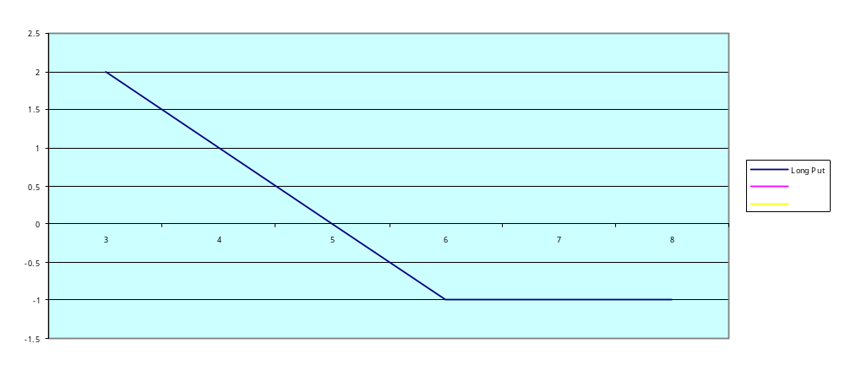
Stock Price

Payoff from writing a put

Payoff / Profit
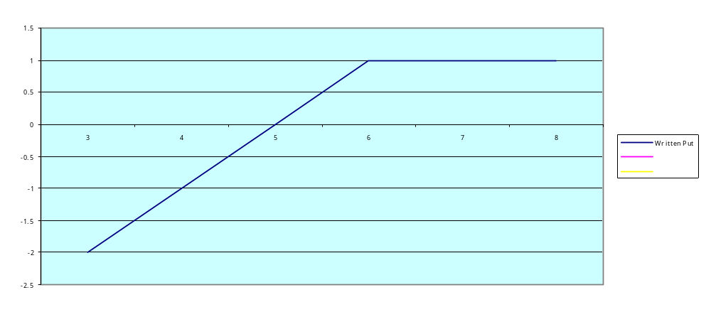
Stock Price

Payoff from buying a straddle

A straddle is a strategy where the trader buys a call and a put on the same underlying.

Payoff / Profit
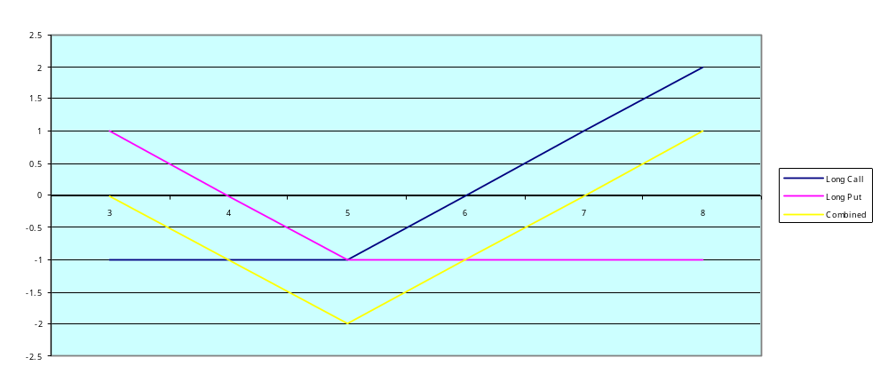
Stock Price

Payoff from writing a straddle

Payoff / Profit
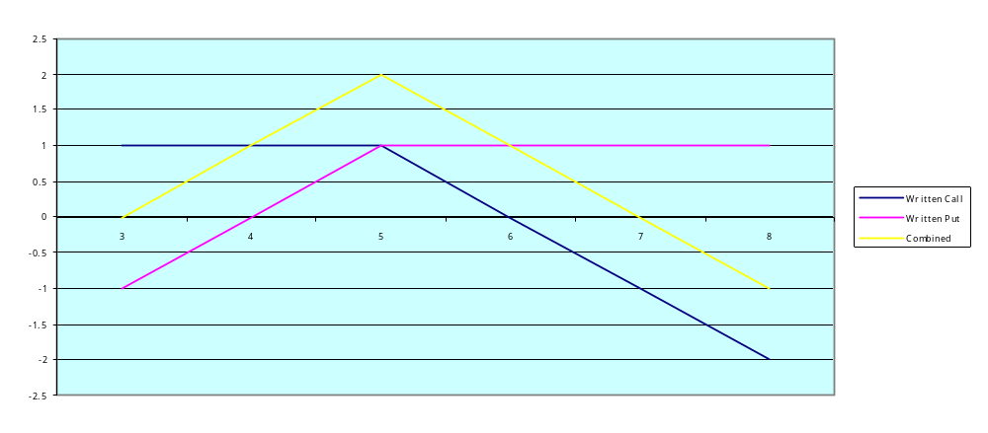
Stock Price

Terminal value of an option at expiration:
On expiration date the terminal value of a call –
= max(0, S – E)
= max(0, Intrinsic value at expiration).
On expiration date the terminal value of a put –
= max(0, E – S)
= max(0, Intrinsic value at expiration)
where,
S = underlying price at expiration
E = strike price (or exercise price) of the option.

Why?
If the price of the option on the expiration date is different from the intrinsic value this would result in arbitrage opportunities.

What is an arbitrage transaction?
An arbitrage transaction permits the trader to lock in risk less (or sure) profits. Usually the net initial investment is zero.

If the IBM price were $310 and a call with strike price $300, expiring on the same day had a price of $9, how would you arbitrage and what would be the risk less profit that you could lock in?
If the above call were priced at $11, how would you arbitrage and what would be the risk less profit that you could lock in?
If the IBM price were $290 and a put with strike price $300, expiring on the same day had a price of $9, how would you arbitrage and what would be the risk less profit that you could lock in?
If the above put were priced at $11, how would you arbitrage and what would be the risk less profit that you could lock in?

General rule:
Arbitragers try to buy under priced assets and sell overpriced assets.
Excessive buying in under priced assets has the effect of raising the price till the fair value is reached.
Excessive selling in overpriced assets has the effect of lowering the price till the fair value is reached.
Thus, arbitragers perform an important economic function.
Their actions ensure that assets are priced fairly by the market.
  - Hedging with options
The concept of hedging:

What is a fully hedged position?
A portfolio which produces zero profits or losses regardless of the direction of underlying price movements.

How to construct a fully hedged position?
Example:
Stock ‘A’ and ‘B’ have a correlation of (-1).
This means that if the price of security A goes up this will produce an exactly opposite downward movement in the price of security B and vice versa.
Thus, buying one share each of stock A and B will produce a fully hedged position as long as the correlation remains constant over time.
Alternate example:
If stock A and B have a correlation of 1, buying (going long) one share of stock A and selling (going short) one share of stock B will produce a fully hedged position as long as the correlation remains constant over time and assuming no restrictions on short selling.

Is being fully hedged always desirable?
A fully hedged position produces no profits or losses.
It is only desirable when the investor is not sure of the future direction of the underlying prices.
If the investor is bullish or bearish he will want to construct a position so as to be able to take advantage of market movements.

Partially hedged positions:
Most of the time an investor will try to construct a partially hedged position, which reduces the risk of loss, at the same time giving some profit potential if the investor’s expectations come true.
A risk less hedge:
Such a hedged position will produce the risk-free rate of return.
Thus a risk less hedge is a way of synthetically creating a risk-free asset using other assets and derivatives.
A synthetically created asset is a portfolio (created using other assets) that replicates the payoff of that asset.

The concept of dynamic hedging:
As prices move and the investor’s view changes, he will adjust his hedge.
If the investor’s expectations are coming true he will prefer to move to an un-hedged (or uncovered or naked) position.
If the investor’s expectations are not coming true he will prefer to move to a fully hedged position.
This concept of periodically adjusting the hedge is termed dynamic hedging.
A fully hedged position will also have to be readjusted (using a dynamic hedging strategy) as prices and correlations between assets in the portfolio change over time.
However, it must also be kept in mind that frequent rebalancing entails high transactions costs.

Options hedging quiz:

Question:
If you were using a call to hedge a long position in IBM would you buy or sell the call?
Answer:
The long position in IBM and the call are positively correlated – one would sell the call to hedge.

Question:
What would you do if you were using a put to hedge a long position in IBM – would you buy or sell?
Answer:
The put and the long position in IBM are negatively correlated – one would buy the put to hedge.

Hedging with options:
When one owns the underlying, one is essentially trying to hedge against falling prices.
In this situation one usually buys put options to hedge.
Two favourite hedging strategies are:
- Protective put
- Portfolio Insurance using put options

Protective put

Payoff structure of a protective put (one long stock and one bought put)
Payoff / Profit
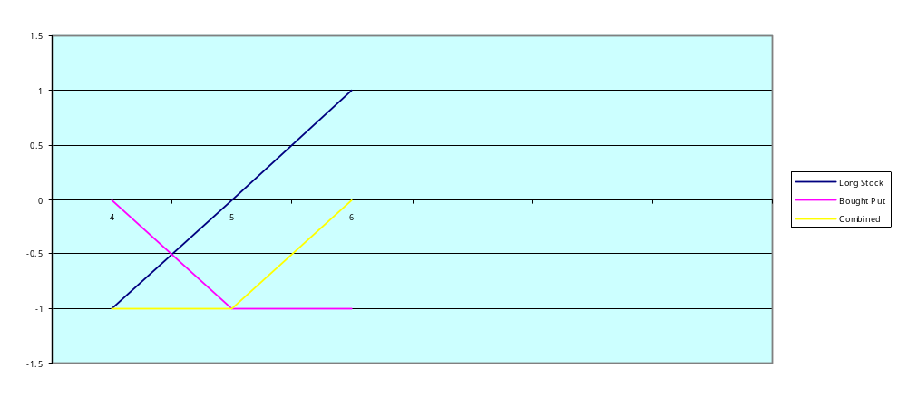
Stock Price

NOTE: The combined payoff looks like the payoff from buying a call.

Payoff structure of a protective put (two long stock and one bought put)
Payoff / Profit
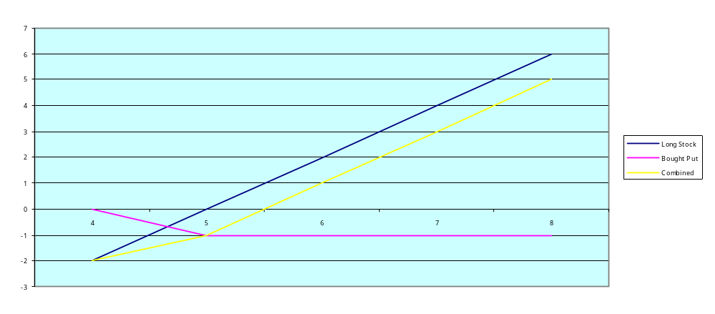
Stock Price

Numerical examples using protective puts:
The IBM price is $298.
Investors A,B, and C, all buy one share each of IBM.
Also:
Investor A buys an European put on IBM with strike $310 and expiration 3 months.
Investor B buys an European put on IBM with strike $300 and expiration 3 months.
Investor C buys an European put on IBM with strike $290 and expiration 3 months.
After 3 months:
After 3 months the price of IBM is $280.
Each investor closes out his position.
Ignoring the price each investor paid for buying the put option, what is the profit or loss made by each investor?
Who paid the highest price for buying the put?
Who paid the lowest price?

Profit or loss
INVESTOR A
- Loss on IBM (280 – 298) | -18
- Profit on put exercised (310 – 280) | 30
- Net Profit | 12
INVESTOR B
- Loss on IBM (280 – 298) | -18
- Profit on put exercised (300 – 280) | 20
- Net Profit | 2
INVESTOR C
- Loss on IBM (280 – 298) | -18
- Profit on put exercised (290 – 280) | 10
- Net Profit | -8

Who paid the highest price for buying the put?
Investor A since at strike 310, the put is most in the money.

Who paid the lowest price for buying the put?
Investor C since at strike 290, the put is most out of the money.

What is the trade-off being faced by the investor in the above situation:
The more in the money the put is, the more protection it will give to the investor if the price of the underlying asset goes down, but the cost of buying the put will also be higher.

Trading insight:
Derivatives trading are full of tradeoffs of the above nature.
Thus this area of finance requires not only mathematical and analytical skills but also a high amount of judgment in terms of possible future price movements.

  - Factors affecting option prices
The factors affecting option prices are as follows.
- Time to maturity.
- Intrinsic value (by how much the option is in the money).
- The intrinsic value in turn is affected by:
- Underlying price.
- Strike price.
- Volatility (or standard deviation) of the underlying.
- Interest rates (risk-free rate)
- Cash dividends

How some of the above factors affect call and put prices:

Time to maturity:
If all other structural factors (strike price etc., whether call or put, whether American or European) are the same, the longer maturity options will have a higher price.
Exceptions:
This rule does not always apply to European puts.
Sometimes options which are deep-in-the-money (and are almost sure to be exercised) have a price, which is very close to the intrinsic value, regardless of the time to maturity.
Similarly, options that are deep-out-of-the money (and are almost sure not to be exercised) have a price, which is very close to zero, regardless of the time to maturity.

Question:
Which of the following options would have a higher price?
- IBM call with strike price of $300 and time to maturity 3 months.
- IBM call with strike price of $300 and time to maturity 6 months.
Answer:
The longer maturity call would be expected to have a higher price, hence the 6 month call should have a higher price.

Underlying price:
As the underlying price rises, the intrinsic value of a call (i.e. S – E) rises and this has the effect of making the call price rise.
As the underlying price rises, the intrinsic value of a put (i.e. E – S) falls and this has the effect of making the put price fall.

Question (a):
Suppose IBM is trading at $310.
A call on IBM with strike $300 and maturity 3 months is trading at $11.
Calculate its intrinsic value.
Solution (a):
The intrinsic value of a call is (S – E)
Hence the intrinsic value is: 310 – 300 = 10.

Question (b):
Suppose IBM is trading at $310.
A put on IBM with strike $300 and maturity 3 months is trading at $14.
Calculate its intrinsic value.
Solution (b):
The intrinsic value of a put is (E - S)
Hence the intrinsic value is: 300 – 310 = -10.

Question (c):
Now suppose that the price of IBM falls to $290. Will the price of the call increase or decrease? Recalculate its intrinsic value after the changes in prices.
Solution (c):
As the underlying price falls the price of the call falls, hence in this case the price of the call will fall as the IBM price falls from 310 to 290.
The new intrinsic value is: 290 – 300 = -10.

Question (d):
Suppose that the price of IBM falls to $290. Will the price of the put increase or decrease? Recalculate its intrinsic value after the changes in prices.
Solution (d):
As the underlying price falls the price of the put rises, hence in this case the price of the put will rise as the IBM price falls from 310 to 290.
The new intrinsic value is: 300 – 290 = 10.

Strike price:
If all other structural factors (time to maturity, whether call or put option, whether American or European option etc.) are the same, higher strike prices will result in lower intrinsic values for calls and higher intrinsic values for puts.
Thus, higher strike prices will result in lower prices for calls and higher prices for puts.

Question:
Which of the following options would have a higher price?
- An IBM call with strike $310 and maturity 3 months.
- An IBM call with strike $300 and maturity 3 months.
If the IBM price is $315 what would be the intrinsic values of the above options?
Answer:
The call with the lower strike price of 300 would have the higher price.
The intrinsic values are:
Strike 310:
(315 – 310) = 5
Strike 300:
(315 – 300) = 15

Question:
Which of the following options would have a higher price?
- An IBM put with strike $310 and maturity 3 months.
- An IBM put with strike $300 and maturity 3 months.
If the IBM price is $290 what would be the intrinsic values of the above options?
Answer:
The put with the higher strike price of 310 would have the higher price.
The intrinsic values are:
Strike 310:
(310 – 290) = 20
Strike 300:
(300 – 290) = 10

Trading strategies using options as investment vehicles:
E.g. you are an investor with a time horizon of one day and notice the following prices:
IBM stock price: $300.
Price of IBM call with strike $300 and maturity 3 months: $5
Price of IBM put with strike $300 and maturity 3 months: $4.

Question:
If you expected the price of IBM on the next day to be $305, which option would you buy and why?
Answer:
As the IBM price increases one would buy the call as the call price would increase.

Question:
If on the other hand you expected the price of IBM on the next day to be $295, which option would you buy and why?
Answer:
As the IBM price decreases one would buy the put as the put price would increase.

Question:
Is the price of a call positively or negatively correlated with the underlying price?
Answer:
As the underlying price increases (decreases) the call price increases (decreases).
Hence the call price is positively correlated with the underlying price.

Question:
Is the price of a put positively or negatively correlated with the underlying price?
Answer:
As the underlying price increases (decreases) the put price decreases (increases).
Hence the put price is negatively correlated with the underlying price.
  - Option pricing principles
NOTATION:
S = Stock price today, E = Exercise price.
T = Time to expiration (expressed as a decimal fraction of a year, i.e. if there are 100 days to expiration, T = 100/365 = .274).
r = Risk free rate (usually the TBill rate is taken as a proxy for the risk free rate).
St = Stock price at option’s expiration, Ca = American call, Ce = European call.
Pa = American put, Pe = European put.
C(E1), and C(E2) : two calls with exercise prices E1 < E2.
C(T1), and C(T2) : two calls with maturity T1 < T2.

The minimum value of a call:
NOTE: Minimum value is not to be confused with lower bound.
For an European call (because the option need not be exercised), the minimum value is zero.
Ce >= 0
For an American call, the minimum value is:
Ca >= max (0, Intrinsic value).
This is because the option need not be exercised, but can be exercised anytime before maturity.

Question:
How would you arbitrage if the price of an in-the-money American call fell below the intrinsic value?
Eg. If the price of IBM is $315 and an American call on IBM with a strike of $300 is trading at $14, how would you arbitrage?
Answer:
Buy the call at 14, exercise it and realize a profit of 15.
i.e. (S – E) = (315 – 300) = 15.
Net profit = 15 – 14 = 1.

The minimum value of a put:
NOTE: Minimum value is not to be confused with lower bound.
For an European put (because the option need not be exercised), the minimum value is zero.
Pe >= 0.
For an American put, the minimum value is:
Pa >= max(0, E – S) >= max(0, Intrinsic value)
This is because the option need not be exercised, but can be exercised anytime before maturity.

Question:
How would you arbitrage if the price of an in-the money American put fell below the intrinsic value?
Eg. If the price of IBM is $285 and an American put on IBM with a strike of $300 is trading at $14, how would you arbitrage?
Answer:
Buy the put at 14, exercise it and realize a profit of 15.
i.e. (E – S) = (300 – 285) = 15.
Net profit = 15 – 14 = 1.

The concept of time value or speculative value:
The price of an American option (for both calls and puts) normally exceeds its intrinsic value because investors usually expect that the longer the time to maturity, the higher is the probability that the intrinsic value may increase in the future, thus resulting in higher profits when the option is eventually exercised.
This excess value, over and above the intrinsic value, which is usually built into the price of an American option, is called the time value or speculative value.
The time value of an American option usually decreases as time passes and on maturity the price converges to:
Max (0, Intrinsic value at expiration).

The maximum value of a call:
C <= S.
The most one can expect to gain from the call is the stock’s value less the exercise price.
Even if the exercise price is zero, no one would pay more for the call than for the stock.

The maximum value of a put:
Terminal value of a put at expiration = max (0, E – S).
Even if the stock price at expiration is zero, the maximum terminal value will be
(E – 0) = E.
Thus the present value of the exercise price is the European put’s maximum possible value.
Pe <= E (1+r)^(-T)
NOTE: the ‘^’ sign stands for “to the power of”.
Since an American put can be exercised at any time before maturity, it’s maximum value is the exercise price:
Pa <= E.

The effect of time to maturity on calls:
If all other structural factors (strike price etc.) are the same, the longer maturity calls will have a higher price.
This is because, for American calls, longer maturity options will tend to have a higher time value.
The above relationship will also hold for European calls.
Exceptions:
A deep-in-the money call (which is almost sure to be exercised) will have a price, which is very close to the intrinsic value, regardless of maturity.
A deep out of the money call (which is almost sure not to be exercised) will have a price, which is very close to zero, regardless of maturity.

The effect of time-to-maturity on puts:
For American puts:
If all other structural factors (strike price etc.) are the same, the longer maturity puts will have a higher price.
This is because, for American puts, longer maturity options will tend to have a higher time value.
Exceptions:
A deep-in-the money American put (which is almost sure to be exercised) will have a price, which is very close to the intrinsic value, regardless of maturity.
A deep-out-of-the money American put (which is almost sure not to be exercised) will have a price, which is very close to zero, regardless of maturity.

The effect of time to maturity:
For European puts:
For European puts the relation between price and time to maturity is more complex.
Two factors are at play:
Time value effect (makes longer maturity options more valuable)
Longer time to sell the stock at the strike price and receive the proceeds
(Since the discounted value of the strike price will be lower for longer maturity options, this will make longer maturity options less valuable).
Usually the time value effect tends to dominate, and even for European puts the longer maturity options will, in general, have a higher value.

The effect of exercise price:
(Recap)
If all other structural factors (maturity etc.) are the same, higher strike prices will result in lower intrinsic values for calls and higher intrinsic values for puts.
Thus, higher strike prices will result in lower prices for calls and higher prices for calls and higher prices for puts.

The effect of exercise price on call option value:
We have two European options Ce(E1) and Ce(E2) with strikes E1 < E2.
We want to know which of the above options will have a higher price.
Consider two portfolios A and B.
Portfolio A consists of a long position in Ce(E1) and a short position in Ce(E2).
The initial value of this portfolio is:
Ce(E1) – Ce(E2).
Portfolio B consists of risk-free bonds (TBills) with face value of (E2 – E1) and maturing at the option’s expiration.
The initial value of this bond = (E2 – E1)(1+r)^(-T).
Where r and T have been defined before.

PORTFOLIO |  | INITIAL VALUE | PAYOFF AT EXPIRATION GIVEN STOCK PRICE AT EXPIRATION
 |  |  | St < E1 | E1 <= St < E2 | E1 < E2 <= St
A |  | +Ce(E1) | 0 | St – E1 | St – E1
 |  | -Ce(E2) | 0 | 0 | -St + E2
 |  | TOTAL | 0 | St – E1 >= 0 | E2 – E1 > 0
B | (E2 – E1)*(1+r)^(-T) |  | E2 – E1>0 | E2 – E1>0 | E2 – E1>0
NOTE: THE ‘^’ SIGN STANDS FOR “TO THE POWER OF”
SINCE PORTFOLIO ‘A’ ALWAYS PRODUCES A PAYOFF OF ZERO OR A POSITIVE AMOUNT, WE CAN CONCLUDE THAT ITS INTIAL VALUE IS ALSO POSITIVE, i.e. Ce(E1) >= Ce(E2).
OTHERWISE THERE WOULD BE ARBITRAGE OPPORTUNITIES.
THIS RESULT WOULD ALSO HOLD FOR AMERICAN CALLS,
HENCE Ca(E1) >= Ca(E2)
Limits on the difference in call prices:
From the above example we also note that portfolio A’s value at expiration is always less than or equal to that of portfolio B, hence their initial values should also follow the same pattern (since no one would pay more for portfolio A than for Portfolio B).
Thus, (E2 – E1)(1+r)^(-T) >= Ce(E1) – Ce(E2)
We have, (E2 – E1) >= Ce(E1) – Ce(E2)
Conclusion:
For two options differing only in strike price, the price difference is less than or equal to the difference in strike prices.

The intuition behind this result:
The advantage of buying an option with a lower exercise price over one with a higher exercise price will not be more than the difference in exercise prices.
Eg. For an investor who owns a call on IBM with strike $300 and is considering replicating it with another call on IBM with strike $295, the most he can gain by the switch is $5.
For American calls, because the options can be exercised early,
(E2 – E1)(1+r)^(-T) (not)># Ca (E1) – Ca (E2)
If the calls were American and both were exercised, the investor would receive (E2 – E1)
This amount would be invested in risk-free bonds and would earn interest over the option’s remaining lives.
At expiration, the investor would have more than (E2 – E1), the payoff from portfolio B.
However, even for American calls:
E2 – E1 >= Ca (E1) – Ca (E2)

The effect of exercise price on put option value:
We have two European options Pe(E1) and Pe(E2) with strikes E1 < E2
We want to know which of the above options will have a higher price.
Consider two portfolios A and B.
Portfolio A consists of a long position in Pe(E2) and a short position in Pe(E1)
The initial value of this portfolio = Pe(E2) – Pe(E1)
Portfolio B consists of a long position in risk-free bonds with a face value of (E2 – E1)

PORTFOLIO |  | INITIAL VALUE | PAYOFF AT EXPIRATION GIVEN STOCK PRICE AT EXPIRATION
 |  |  | St < E1 | E1 <= St < E2 | E1 < E2 < St
A |  | -Pe(E1) | -E1+St | 0 | 0
 |  | +Pe(E2) | E2 - St | E2 - St | 0
 |  | TOTAL | E2 – E1>0 | E2 – St > 0 | 0
B | (E2-E1)*(1+r)^(-T) |  | E2 – E1 > 0 | E2 – E1 > 0 | E2 – E1 > 0
NOTE: (E2 – E1)*(1+r)^(-T) is the discounted value of (E2-E1)
For portfolio A, all outcomes are non-negative; hence in order to prevent arbitrage, the initial value must also be non-negative.
Thus, Pe(E2) >= Pe(E1)
This result will also hold for American puts.
Hence, Pa(E2) >= Pa(E1)

Limits on the differences in put prices:
From the above example, we also note that portfolio B’s outcomes are never less than portfolio A’s.
Hence the initial values must also follow the same relation (since no one would pay more for Portfolio A than for Portfolio B).
Thus, (E2 – E1)(1+r)^(-T) >= Pe(E2) – Pe(E1)
And since,
(E2-E1) >= (E2 – E1)(1+r)^(-T) >= Pe(E2) – Pe(E1)
We have, (E2 – E1) >= Pe(E2) – Pe(E1)

For American puts:
For American puts, because the options can be exercised early,
(E2 – E1)(1+r)^(-T) (not)># Pa(E2) – Pa(E1)
If the puts were American and both were exercised, the investor would receive (E2 – E1).
This amount would be invested in risk-free bonds and would earn interest over the options’ remaining lives.
At expiration, the investor would have more than (E2 – E1), the payoff from portfolio B.
However, even for American puts,
(E2 – E1) >= Pa (E2) – Pa (E1)

The lower bound of a European call:
NOTE: Lower bound is not to be confused with minimum value.
The minimum value of an American call is,
Ca >= max (0, S – E)
The lower bound of a European call will be higher.
Consider two portfolios A and B.
Portfolio A consists of a single share of stock.
Portfolio B consists of a long European call and risk-free TBills with face value of ‘E’.

PORTFOLIO | INITIAL VALUE | PAYOFF AT EXPIRATION GIVEN STOCK PRICE AT EXPIRATION
 |  | St <= E | St > E
A | S | St | St
B | Ce + E(1+r)^(-T) | E | (St – E)+E = St
NOTE: The ‘^’ sign stands for “to the power of”
The return on portfolio B is always at least as large as the return on portfolio A.
Hence, in order to prevent arbitrage, the initial values must also follow the same relationship.
Thus, Ce + E(1+r)^(-T) >= S
Rearranging, Ce >= S – E(1+r)^(-T)
If [S-E(1+r)^(-T)] is negative, we invoke the rule that the minimum value of a call is zero.
Hence, the lower bound of a European call:
Ce >= max[0, S – E(1+r)^(-T)]

American versus European calls:
Since, (S – E) <= S – E (1+r)^(-T), the minimum value of an American call is lower than or equal to the lower bound of an European call.
However, since exercising an option is never mandatory, Ca > = Ce, because an American option is like an European option with added features and thus must be more expensive or at least as expensive.
Hence, the lower bound of an American call is the same as that of an European call,
Ca >= max [0, S – E (1+r)^(-T)]

Lower bound for calls on dividend paying stocks:
If the stock pays dividends, and the stock price minus the present value of dividends is:
Sd = S – (sigma, j = to N)Dj(1+r)^(-tj)
Then the lower bound is restated as:
Ce >= max [0, Sd – E(1+r)^(-T)]

The lower bound of a European put:
NOTE: Lower bound is not to be confused with minimum value.
The minimum value of an American put is,
Pa >= max (0, E – S)
The lower bound of a European put will be lower.
Consider two portfolios A and B.
Portfolio A consists of a single share of stock.
Portfolio B consists of a short position in an European put and a long position in risk-free bonds with a face value of E and a present value of E(1+r)^(-T)

PORTFOLIO | INITIAL VALUE | PAYOFF AT EXPIRATION GIVEN STOCK PRICE AT EXPIRATION
 |  | St <= E | St > E
A | S | St | St
B | E(1+r)^(-T) - Pe | E – (E – St) = St | E
Portfolio A’s outcome is always at least as favorable as portfolio B’s
Therefore no one would be willing to pay more for portfolio B than for portfolio A (in terms of Initial value).
Hence, S >= E(1+r)^(-T) – Pe
Rearranging, Pe >= E(1+r)^(-T) – S
Since the value of a put cannot be negative, the lower bound of an European put is:
Pe >= max[0, E(1+r)^(-T) – S]
This is lower than or equal to the minimum value of an American put since
(E-S) >= E(1+r)^(-T) – S.

Lower bound of European puts on dividend paying stocks:
If the stock pays dividends, and the stock price minus the present value of dividends is,
Sd = S – (sigma, j = 1 to N) Dj(1+r)^(-tj)
Then the lower bound is restated as:
Pe >= max[0, E(1+r)^(-T) – Sd]

American versus European puts:
An American put is exactly like an European put but with additional features, it must be worth at least as much.
Hence, Pa >= Pe
Since the minimum value of an American put is higher than the lower bound of an European put, the minimum value of an American put will also be its lower bound.
Thus for American puts, minimum value = lower bound.
Or, Pa >= max (0, E – S)
i.e. Pa >= max(0, intrinsic value)
This is the minimum value and the lower bound.

The effect of volatility of the underlying asset on option value:
E.g. Consider a put and a call on IBM with strike $300.
Suppose the stock price is equally likely to be at 280, 290, 310, or 320 at expiration.
The call is equally likely to be worth 0,0,10, and 20 at expiration.
The put is equally likely to be worth 20,10,0, and 0 at expiration.
If the stock’s volatility increases so that it is equally likely to be at 270, 290, 310, or 330 at expiration.
From a stockholder’s point of view, the stock is now riskier.
However now the call is equally likely to be worth 0, 0, 10, and 30 at expiration, which on an average is a higher value than before.
Similarly the put is now equally likely to be worth 30, 10, 0 and 0 at expiration, which on an average is a higher value than before.
Hence, an increase in volatility usually results in an increase in call and put prices.

  - Option pricing model
    - Black Scholes
NOTATION:
S = Stock price today, E = Exercise price.
T = Time to expiration (expressed as a decimal fraction of a year. ie. If there are 100 days to expiration, T = 100/365 = .274)
R = Risk-free rate (usually the TBill rate is taken as a proxy for the risk-free rate)
St = Stock price at option’s expiration, Ca = American call, Ce = European call.
Pa = American put, Pe = European put.

Basic assumptions behind the model:
The rate of return on the stock follows a lognormal distribution.
This means that the logarithm of the return on the stock is constant throughout the option’s life.
There are no taxes or transactions costs.
The stock pays no dividends (adjustments to the model are required if the stock pays dividends)
The calls are European (The Black Scholes model is not so effective for valuing American Options, specially if the stock pays dividends)

The Black Scholes formula:
C = S.N (d1) – E.e^(-rT). N(d2)
Where,
.d1 = [ln(S/E) + (r + {(vol)^2}/2).T]/(vol).(sqrt(T))
.d2 = d1 – (vol).(sqrt(T))
N(d1), N(d2) = cumulative normal probabilities evaluated at d1 and d2 respectively.
Vol = annualized volatility of the continuously compounded return on the underlying.
.r = continuously compounded risk-free rate (note that here ‘r’ stands for the continuously compounded risk-free rate).

Continuous Compound Interest:
Some relevant interest formulae are given below:
Simple interest: A = P(1+rT)
Compound interest: A = P(1+r/m)^(mT)
Continuous compound interest: A = Pe^(rT)

Returning to the Compound interest formula:
A = P (1+r/m)^(mT)
Where,
P is the principal amount.
r is the rate of interest per year.
m is the number of compounding periods per year.
T is the time period expresses in years.
A is the amount after interest at the end of T years.
Suppose P, r, T are held constant and ‘m’ is increased without bound.
Will the amount ‘A’ increase without bound or will it tend to some limiting value?
Starting with P = $100, r = 0.08, and T = 2 years, we construct the following table.
COMPOUNDING FREQUENCY | M | A = 100(1+0.08/m)^(2m)
Annually | 1 | 116.640
Semi-annually | 2 | 116.985
Quarterly | 4 | 117.165
Weekly | 52 | 117.336
Daily | 365 | 117.349
Hourly | 8760 | 117.351

It can be shown that,
P (1+r/m)^(mT), gets closer and closer to Pe^(rT), as the number of compounding periods ‘m’ gets larger and larger.
This is referred to as continuous compounding.

How to calculate a continuously compounded rate of return:
Since, A = Pe^(rT),
Hence, A/P = e^(rT)
And, ln(A/P) = rT.
Thus, if the stock price today is 300 and a year ago it was 290, the continuously compounded rate of return is,
.ln(300/290) = rT = 0.0339
Since T = 1 in this example, the continuously compounded rate of return r = 3.39%

Calculating volatility based on historical data:
Eg. Take a sample of monthly closing prices for the past 5 years.
(The sample could also be constructed differently, for instance, daily opening prices for the past one year. A different sample would give a different estimate of volatility. However, care must be taken to ensure that the sample is consistent, for instance if daily closing prices are taken, then the full sample must contain daily closing prices, not any other price. Choosing the appropriate sample would require the skill and judgment of the trader)
Compute monthly stock price returns by dividing each price by the previous month’s price.
Compute continuously compounded returns by taking the log of the monthly returns.
Compute the standard deviation of the continuously compounded returns. This is the monthly volatility.
Annualize the monthly volatility by multiplying by the square root of 12.

Using the normal distribution tables:
One can take any normally distributed random variable, convert it to a standard normal or ‘z’ statistic, and use the normal distribution table to determine the probability that an observed value of the random variable will be less than or equal to the required value.
For positive values:
Suppose we want to know the probability of observing a value of ‘z’ less than or equal to 1.57
Go to the table and look down the first column for 1.5, then move over to the right under the column labelled 0.07 (i.e. the 1.5 and 0.07 add up to the ‘z’ value, 1.57).
The entry in the 1.5 row / 0.07 column is .9418
This is the probability, in a normal distribution of observing a value of ‘z’ less than or equal to 1.57
For negative values:
Suppose the value of ‘z’ is less than zero; say -1.12
We look for the appropriate value for a positive 1.12
In the row / 0.02 column is the value .8686
We subtract this number from 1 to get .1314

Why the table need not show negative values:
Because the table is symmetric, it is not necessary to show negative values.
The probability of observing a value less than or equal to -1.12 is the same as that of observing a value greater than or equal to 1.12
The probability of observing a value greater than or equal to 1.12 is 1 minus the probability of observing a value greater than or equal to 1.12

  - Put-Call Parity
Consider two portfolios A and B.
Portfolio A consists of one share of long stock and a long European put.
Portfolio B consists of a long European call with the same exercise price and maturity, and risk-free TBills with a face value of ‘E’ and the same maturity as that of the options.
PORTFOLIO | INITIAL VALUE | PAYOFF AT EXPIRATION GIVEN STOCK PRICE AT EXPIRATION
 |  | St <= E | St > E
A | S | St | St
 | Pe | E – St | 0
 | TOTAL | E | St
B | Ce | 0 | St – E
 | E(1+R)^(-T) | E | E
 | TOTAL | E | St

The terminal values of portfolios A and B are equal
Hence, the initial values must also be equal in order to prevent arbitrage.
Hence, S + Pe = Ce + E(1+r)^(-T)
This is referred to as put-call parity.
Rearranging,
Ce = Pe+S-E(1+r)^(-T)
Pe = Ce-S+E(1+r)^(-T)

Put Option pricing using the Black Scholes model:
For European options, put-call parity states,
Pe = Ce – S + E(1+r)^(-T)
Restating this using continuous compounding gives,
Pe = Ce – S + E.e^(-rT)
Substituting the Black Scholes value of the call, we get
Pe = S.N(d1) – E.e^(-rT).N(d2) – S + E.e^(-rT)
= E.e^(-rT).[1 – N(d2)] – S.[1 – N(d1)]

Black Scholes Model for dividend paying stocks:
If the stock pays dividends, we insert Sd for S, where Sd is the stock price minus the present value of dividends. The rest of the formula is the same.
For American options, put-call parity does not hold so precisely:
For American options, put-call parity is stated as inequalities:
Ca + E + (sigma, j = 1 to N) Dj(1 + r)^(-tj) >= S + Pa >= Ca + E(1 + r)^(-T)

Valuing American options:
American options usually have a higher price than European options (as we have already seen).
The Black Scholes model is only effective for valuing European options.
The Black Scholes model can also be used to value American calls on non-dividend paying stocks.
Because, as we have already seen, it is never optimal to exercise early an American call on a non-dividend paying stock and its value will always equal the value of an otherwise identical European option.
All other American options are usually valued using other option pricing models like the binomial model.
The Black Scholes model is not effective for valuing these options.

The early exercise of American calls on non-dividend paying stocks:
Exercising the call will result in a cash flow of (S-E)
However, the lower bound of the call’s price is:
Max [0, S – E (1+r)^(-T)]
Since [S – E (1+r)^(-T)] >= [S-E], selling the call in the market rather than exercising it would always produce a higher cash flow.
Hence it is never optimal to exercise an American call on a non-dividend paying stock before maturity.

The early exercise of American calls on dividend paying stocks:
The stock price tends to fall by the amount of the dividend on the ex-dividend date.
A drop in stock price results in a decrease in intrinsic value of a call thus resulting in a decrease in the call price.
The investor could avoid this loss in value if the call is exercised immediately before the stock goes ex-dividend.
This is the only time the call could be exercised early, at all other times it will be more profitable to sell it on the open market.
This does not mean that exercise will definitely occur at the ex-dividend instant.
Exercise will not occur if the amount of dividends is insignificant or if the investor is bullish.
The value of the right to exercise early is what distinguishes an American call from an European call. That right is worth something only when there are significant dividends on the stock.

The early exercise of American puts:
Suppose there are no dividends.
If the company goes bankrupt and its stock goes to zero, the put will be exercised and the holder will receive its intrinsic value of (E-0).
This is not the only situation prompting early exercise.
If there are dividends:
Dividends will drive the stock price down and make it more optimal to hold on to the option rather than exercise it, since the put value will rise as the stock price falls.

Early exercise and the impact of liquidity:
For illiquid American options, it may be worthwhile to exercise early if the option is not being traded on the market.
The same holds true for OTC options, which are not traded, in the market.

  - Implied Volatility

Usually the fair value of options is calculated using pricing models, and the trader’s own estimate of volatility.
Sometimes, however, it is also interesting to observe actual market prices of options and work backwards, using the Black Scholes model, to arrive at the volatility which is “implied” by a given option price.
Since actual market prices are used in this calculation, the implied volatility is a sort of a market consensus on what the volatility should be.
If the implied volatility of an option increases, it usually signifies that many market participants expect the underlying asset price to exhibit more pronounced (or volatile) up or down movements.

Implied volatility smile:
Research suggests that the implied volatility tends to be increasingly higher the more in or out of the money the option is.
Thus, graphs of the implied volatility against the exercise price usually produce a ‘U-shaped’ plot known as the “implied volatility smile”.
This indicates that the Black Scholes model is not perfect since there can be only one volatility estimate for an asset at a particular point in time.
However, the Black Scholes model is widely used by traders since it is simple and provides a reasonably good approximation for the actual price.

  - Risk Management
    - The Greeks
These are derivatives of option prices with respect to various variables and are measures used in risk management.
From the Black Scholes formula we may observe that the option price function depends on the following variables:
- Stock price / underlying price.
- Exercise price
- Risk-free rate.
- Time to expiration.
- Volatility

Derivatives of the above variables with respect to the call or put prices, give measures of how much the call or put price would change in response to a small change in the above variables.
These measures are useful tools in risk management for option portfolios.

Delta:
Delta measures the change in the option price in response to a small change in the stock price.
It is the derivative of the option price with respect to the stock price.

Call Delta:
Call Delta = N(d1)
Since N(d1) is a probability, the call delta is always positive and ranges from zero to 1.
This indicates that call prices are positively related to stock prices.
When the call is deep-out-of-the money, the call delta will be close to zero.
When the call is deep-in-the money, the call delta will be close to one.

Put Delta:
Put Delta = N(d1) – 1
The Put Delta is always negative and ranges from zero to (-1).
This indicates that put prices are negatively related to stock prices.
When the put is deep-out-of-the money, the put delta will be close to zero.
When the put is deep-in-the money, the put delta will be close to (-1).

Gamma:
Gamma measures the change in the delta in response to a small change in the stock price.
It is the second derivative of the option price with respect to the stock price.
Call Gamma = Put Gamma.
Gamma is always positive and is largest when the option is at-the money.
When the option is deep-in or out of the money, the Gamma approaches zero.

Rho:
Rho measures the change in option prices in response to a small change in the risk-free rate.
It is the derivative of the option price with respect to the risk-free rate.
The call rho is always positive, indicating that the relationship between call prices and the risk-free rate is a positive relationship.
The put rho is always negative; indicating that the relationship between put prices and the risk-free rate is a negative relationship.

Vega (or Kappa):
Vega measures the change in option prices in response to a small change in volatility.
It is the derivative of the option price with respect to volatility.
Both call and put prices are positively related to changes in volatility.

Theta:
Theta measures the change in option prices in response to a small change in time to expiration.
It is the derivative of the option price with respect to time to expiration.
As time to expiration decreases call values decrease.
For puts the relationship is more complex.
American put values decrease as time to expiration decreases.
However, European put values usually decrease but may sometimes increase as time to expiration decreases.

Delta, Gamma, Rho, Vega, Theta of the underlying Stock / Asset:
The Delta of a stock / asset is one.
The Gamma, Rho, Vega and Theta of a stock / asset are assumed to be zero.
Delta, Gamma, Rho, Vega, Theta of Portfolios:
For portfolios, the Delta, Gamma, Rho, Vega and Theta are calculated as a weighted average of the individual securities.
The weights are assigned relative to the values of each security with respect to total portfolio value.

  - Delta hedging.
Delta hedging consists of making additions to the portfolio with securities in appropriate amounts so as to create a delta-neutral position (net portfolio delta of zero).
Problems with Delta calculations:
- Delta is accurate only for a small change in the stock price. Delta changes when the stock price moves by a large amount.
- Delta is also sensitive to the passage of time and also to changes in other pricing variables. As time passes, or the other variables change, Delta changes even if the stock price remains the same.

Implications of problems with Delta calculations:
These problems make Delta hedging complicated and make it necessary to rebalance the hedge and pursue a dynamic hedging strategy, without losing sight of the fact that rebalancing entails transactions costs.

Delta hedging problem:
E.g. Consider the following situation:
IBM stock is trading at $300.
European calls and puts on IBM with strike prices of 295 and 305 are available for trading. All the options have a remaining maturity of 30 days.
The volatility of IBM is 0.3 and is assumed to remain constant over the trading horizon.
The risk-free rate (continuously compounded) is 6% and is also assumed to remain constant over the trading horizon.

What would you do (buy/sell and in what quantity) if?
- You owned 10,000 shares of IBM and wanted to construct a Delta Neutral position using the 295 call
- You were short 1000, 295 calls and wanted to construct a Delta Neutral position using the 305 call
- You were long 10,000 shares and short 1000, 295 calls and wanted to construct a Delta Neutral position using the 305 put.
Solution:
For E = 295
.d1 = [ln(300/295) + (0.06+{(0.3)^2}/2)(0.082)]/(0.3)(sqrt(0.082))
= [ln(1.0169)+(0.06+0.045)(0.082)]/0.0859
= [0.01676 + 0.00861]/0.0859
= 0.2953
.d2 = 0.2953 – 0.0859 = 0.2094
N(d1) = 0.6179
N(d1) – 1 = -0.3821

For E = 305

.d1 = [ln(300/305) + (0.06+{(0.3)^2}/2)(0.082)]/(0.3)(sqrt(0.082))
= [-0.0165 + 0.00861]/0.0859
= -0.0922
. N(d1) = 1 – 0.5359 = 0.4641
N(d1) – 1 = -0.5359

SECURITY | DELTA
IBM | 1
C(E295) | 0.6179
C(E305) | 0.4641
P(E295) | -0.3821
P(E305) | -0.5359

We compute the portfolio delta:

SECURITY | QTY. | TOTAL DELTA
IBM | 10,000 | 10,000

We need to sell C(E295) since its delta is positive and we need a total C(E295) delta of
-10,000 in order to be delta neutral
Hence, go short to the tune of -10,000/0.6179
= -16,184 C (E295) calls.

We compute the portfolio delta:

SECURITY | QTY. | TOTAL DELTA
C (E295) | -1000 | -617.9

We need to buy C (E305) since its Delta is positive and we need a total C(E305) Delta of 617.9 in order to be Delta Neutral.
Hence, buy 617.9/0.4641
= 1331 C (E305) calls.

We compute the portfolio delta:

SECURITY | QTY. | TOTAL DELTA
IBM | 10,000 | 10,000
C(E295) | -1,000 | -617.9
 | NET | 9,382.1

We need to buy P (E305) since its Delta is negative and we need a total P (E305) Delta of -9,382.1 in order to be Delta Neutral.
Hence, buy -9,382.1/-0.5359
= 17,507 P (E305) puts.

- Credit derivatives
  - Conceptual aspects / definitions
The following definitions are based on ISDA (International Swaps And Derivatives Association) Credit Derivatives Definitions 1999.

Credit Derivatives:
These are OTC financial contracts.
Financial instruments that permit one party to transfer credit risk of a reference asset, which it owns, to another party without actually selling the asset.
Un-bundles credit risk from the credit instrument and trades it separately.
Financial contract outlining potential exchange of payments in which at least one leg of the cash flow is linked to the performance of a specified underlying credit sensitive asset

Protection Seller:
Party that contract to receive premia or interest-related payments in return for assuming the credit risk on an asset or group of assets from the protection buyer.
Also known as credit risk buyer or guarantor.

Protection Buyer:
Party that contract to transfer the credit risk on an asset or group of assets to the protection seller.
Also known as credit risk seller or beneficiary.

Premium:
The fee the protection buyer pays to the protection seller as in the case of insurance business.

Credit event:
A scenario or condition agreed between the contracting parties that will trigger the credit event payment from the protection seller to the protection buyer.
Usually such events include bankruptcy, insolvency, merger, cross acceleration, cross default, failure to pay, repudiation, restructuring, delinquency, price decline, rating downgrade of the underlying asset / issuer.

Credit event payment or settlement:
The amount that is paid following a credit event
This is defined in the contract.
Normally one of three following types:
Physical delivery.
Cash settlement.
Fixed amount.

Physical delivery:
Payment of par or other specified value in exchange for physical delivery of the reference asset (or a variety of assets) of the reference entity as allowed under some contracts.

Cash settlement:
Payment of par less recovery value
The reference asset will normally retain some value after a credit event has triggered settlement of the contract.
The recovery value is normally determined at a date up to 3 months after the credit event, by a dealer poll or auction.

Fixed amount:
Payment of a fixed amount

Reference Asset:
Asset to which payments under the credit derivative contract are referenced or linked
Also called reference obligation.

Underlying asset:
This is usually also the reference asset.
It is the asset on which the protection buyer buys credit risk protection.
Could be a bank loan, corporate bond/ debenture, trade receivable, emerging market debt, municipal debt etc., or a portfolio of credit products.

Reference entity:
The entity upon whose credit the contract is based.

Deliverable obligation:
What assets are eligible for delivery as settlement in a physical delivery contract? It usually includes a reference asset but may also be broader to include other assets.

Obligations:
What assets may trigger a credit event?
Usually the same as underlying asset / reference asset

Sponsor:
The entity that places the portfolio in a special purpose vehicle for issue of notes – in case that structure is adopted and notes have to be issued.

Senior debt:
That portion of funding in case of structuring of a collateralised debt issue (CDO), which has the lowest, risk weight, or the highest rated debt.

Mezzanine debt:
Debt in ascending order of risk weights or descending order of rankings
Lower level debt than senior debt.

Equity:
Balance funding with high-risk weight
Lower rated than mezzanine debt.
  - Types of credit derivatives
The following are the main types of credit derivatives.
- Credit Default Swap (CDS)
- Credit Default Option
- Credit linked note
- Credit Linked Deposits (CLDs)
- Repackaged notes.
- Collateralised debt obligations (CDOs)
- Total return swaps
- Credit spread options.

    - Credit default swap (CDS)
The Credit default swap (CDS) provides protection against a default by a particular company.
The company is a “reference entity”.
Default by the company is a “credit event”.
The buyer of the CDS makes periodic payments (akin to insurance premiums) and in return obtains the right to sell a certain amount of a particular bond issued by the reference entity for its face value.
Can be cash settled or settled by delivery of bonds.
It is a bilateral derivative contract on one or more reference assets.
Protection buyer pays a fee through the life of the contract in return for a credit event payment by the protection seller following a credit event of the reference entities.
In most cases the protection buyer makes quarterly payments to the protection seller.
The periodic payment is typically expressed in annualised basis points of a transaction’s notional amount.
If the credit event occurs then the protection seller makes physical delivery or cash settlement depending on the terms of the credit default swap.

    - Credit default option
It is a kind of credit default swap (CDS) where the fee is paid fully in advance.

    - Credit linked note
It is a combination of a regular note and a credit option.
Since it is like debt, it is an on-balance sheet equivalent of a credit default swap.
The coupon or price of the note is linked to the performance of a reference asset.
It offers lenders a hedge against credit risk and investors a higher yield for buying a credit exposure synthetically rather than from the debt market.
Credit linked notes are generally created through a special purpose vehicle (SPV), or trust, which is collateralised with highly rated securities.
Credit linked notes can also be issued directly by a bank or financial institution.
Investors buy the securities from the trust (or issuing bank) that pays a fixed or floating coupon during the life of the note.
At maturity the investors receive par unless the referenced credit defaults or declares bankruptcy, in which case they receive an amount equal to the recovery rate.

    - Credit linked deposits (CLDs)
Also called credit linked certificates of deposit.
These are structured deposits with embedded default swaps.
They are usually deposits along with a default swap that the investor sells to the deposit taker.
Default contingency can be based on a variety of underlying assets, including a specific corporate loan or security, a portfolio of loans or securities or sovereign debt instruments, or even a portfolio of contracts, which give rise to credit exposure.
Structure can include an interest rate or foreign exchange swap to create cash flows required by investor.
The depositor is selling protection on the reference asset and earning a premium in the form of a yield spread over plain deposits.
If a credit event occurs over the tenure of the credit linked deposit, the deposit is paid and the investor would get the deliverable obligation instead of the deposit amount.
    - Repackaged notes
This involves placing securities and derivatives in a special purpose vehicle (SPV). The SPV then issues customized notes that are backed by the instruments placed.
Difference between repackaged notes and credit-linked deposits is: credit linked deposits are default swaps embedded in deposits / notes; repackaged notes are issued against collateral – which typically includes cash, bonds, and derivatives.
Any issue of repackaged notes by the SPV has recourse only to the collateral of that issue.

    - Collateralised debt obligations (CDOs)
These are specialized repackaged offerings that typically involve a large portfolio of credits.
It is usually the issuance of debt by a SPV based on collateral of underlying credits
Difference between a repackaged note and a collateralised debt obligation is as follows: repackaged notes usually deliver the entire risk inherent in the underlying collateral to the investor; collateralised debt obligation involves horizontal splitting of that risk and categorizing investors into senior class debt, mezzanine debt and junior class debt.
In this kind of contract -
If bonds are issued it is called collateralised bond obligations.
If loans are issued it is called collateralised loan obligation.

    - Total Return Swaps
Involves the total return on a portfolio of credit sensitive assets being swapped for LIBOR or another benchmark rate.
Enables banks with heavy loan concentrations to diversify their credit risks.
These are bilateral financial contracts designed to synthetically replicate the economic returns of an underlying asset or a portfolio of assets for a pre-specified time.
One counter party the total return payer, pays the other counter party the total return receiver, the total return of a specified asset, the reference asset.
In return the total return receiver makes regular floating payments (which represent a funding cost).
In effect it allows the receiver to obtain the economic returns of an asset without having to fund the assets on the balance sheet.
If the underlying declines in value by more than the coupon payment the receiver must pay the negative total return in addition to the funding cost or floating rate payment.
In extreme cases the receiver can be liable for loss in case of default on the reference asset.
In contrast to credit default swaps, this structure transfers not only credit risk (improvement or deterioration in credit profile) but also market risk (increase / decrease in market prices).
Payments are exchanged among counter parties upon changes in market valuation of the underlying, in addition to the occurrence of a credit event, as is the case with credit default swaps.

    - Credit Spread Options
This is an option that provides a payoff when the spread between the yields on two assets exceeds some pre-specified level.

- Weather derivatives
  - Weather products on Chicago Climate Exchange (CCX)
The CCX undertakes emissions trading.
That is the trading of rights to emit greenhouse gases such as carbon dioxide and sulphur dioxide.
The exchange aims to bring together buyers and sellers of greenhouse gas emissions rights.
The regulator (which could be the government) allots each source a certain number of emissions credits.
If a polluter’s emissions exceed the number of allotted credits, it can purchase additional credits from the open market.
Conversely someone with extra credits can sell them in the market.
Concerned groups can also help in reducing emissions by purchasing carbon credits from the market and by not letting them be used.
The exchange trades not just carbon dioxide but also other greenhouse gases such as sulphur dioxide, nitrous oxide etc.
All other gases are converted to equivalent tonnage of carbon dioxide.

Instruments used:
Exchange allowances – these are permits for the holder to emit a certain volume of a greenhouse gas.
Exchange offsets – a project that reduces emissions such as the use of wind or hydropower.
Initially the CCX used the auction route for trading.
In the auction process, sealed bids are submitted to the exchange for purchasing emission rights.
In future continuous electronic trading will be used.

  - Weather products on Chicago Mercantile Exchange (CME)
Some weather derivatives definitions are given below:
Heating Degree Days (HDD):
For each day this is max (0, 65 – A) where ‘A’ is the average of the highest and lowest temperature in degree Fahrenheit.
Cooling degree days (CDD):
For each day this is max (0, A – 65)

A typical product is a forward contract or an option on the cumulative CDD or HDD during a month.
Weather derivatives are often used by energy companies to hedge the volume of energy required for heating or cooling during a particular month.
CME began trading seasonal weather products apart from the normal monthly products.
Both the monthly and seasonal products (futures / options on futures) are based on the HDD and CDD indices.
However, seasonal contracts are 5 months in length – summer: May to Sept., winter: Nov to March.
As at 2003 end, the cities available for seasonal trading were Chicago, Cincinnati, New York.
For monthly contracts the cities were Atlanta, Chicago, Cincinnati, New York, Dallas, Philadelphia, Portland, Tucson, Des Moines, Las Vegas.
Each city has a different index of HDD and CDD and different futures / options on futures contracts are traded on it.
CME offers futures and options on futures based upon indices of Heating Degree Days (HDDs) and Cooling Degree Days (CDDs).
These indices are for selected population centres and energy hubs with significant weather related risks throughout the US.

Cities for HDD and CDD indices are chosen as follows:
- Based upon population
- Based on variability in seasonal temperatures
- Based on the activity seen in the OTC market in HDD and CDD derivatives

What is a degree-day?
A degree-day is the measure of how much a day’s average temperature deviates from 65 degree Fahrenheit.
The average daily temperature is the average of the day’s maximum and minimum temperature on a midnight-to-midnight basis.
The Utility industry uses 65 degree Fahrenheit as a baseline because years ago that were the temperature at which furnaces would be switched on.
Now it is used as a benchmark with the assumption being that for each degree below 65, consumers will use more energy to heat their homes and for each degree above 65, the populace will consume more energy to run their air conditioners.
However, even though 65 is the industry standard, there are still different regional sensitivities.
E.g. A resident of Los Angeles may see 65 Fahrenheit as close to the Freezing Point, while in Minnesota it might be considered as tropical.

The HDD and CDD Indices:
A Heating Degree Day (HDD) measures the coldness of the daily temperature compared to a standard of 65 degrees Fahrenheit.
Daily HDD =
Max(0, 65 degree Fahrenheit – Daily Average temperature)
An average daily temperature of 40 would give you a daily HDD of 25.
If the average temperature were 67, then the daily HDD is zero.

The HDD Index:
The CME HDD Index is an accumulation of daily HDDs in a calendar month.
The value of each index point is $100.
Eg. Assume the average daily HDDs for a city in November were 25.
With 30 days in November the HDD index could be 25*30 days = 750.
Thus the nominal value of the futures contract would be 750*$100 = $75,000.

The CDD Index:
A cooling degree day (CDD) measures the warmth of the daily temperature compared to a standard of 65 degree Fahrenheit.
Daily CDD =
Max (0, daily average temperature – 65 degree Fahrenheit).
An average daily temperature of 75 would give you a daily CDD of 10.
If the average temperature were 58, the daily CDD would be zero.
Like the HDD index, the CME CDD index is an accumulation of Daily CDDs during a calendar month.
$100 is attached to each CDD for final cash settlement.
E.g. Assume the average daily CDDs for a city in June were 10 (75 degree Fahrenheit – 65 degree Fahrenheit)
With 30 days in June, the CDD index could be 300 (10 daily CDDs*30days).
With a CDD index of 300 for June, the nominal value of a futures contract on that city would be $30,000 (300 CDD index * $100).

Volumetric Risk:
CME contracts and OTC weather derivatives can be used to hedge the volumetric risk a utility or power provider may face as the result of adverse weather.
E.g. Utilities, by using weather derivatives are not trying to hedge price risk but volumetric risk – i.e. lower levels of consumer demand for their product during periods of adverse weather.
Volumetric risk e.g.
When HDDs and CDDs are unreasonably low the volumetric risk can severely affect a utility’s revenue stream.
This can be hedged using weather derivatives.
Hedging volumetric risk:
If a power company’s future revenue stream were vulnerable to a summer in which there was less need for air conditioning (i.e. an unusually cold summer, hence an unusually low CDD).
The company could choose to sell CME CDD futures or to purchase CDD put options.
If the forecast was for an unusually hot summer (i.e. an unusually high CDD),
The company might decide to hedge with a purchase of an out-of-the money CDD call.
A hot summer would benefit the power company through higher volume of sales since people would need more air-conditioning.
But higher volumes would lead to an increase in costs and this can be hedged using CDD calls.
Weather derivatives to hedge agricultural commodity price risk:
Risk managers in the agricultural sector can employ weather derivatives in hedging strategies.
This would be in addition to price risk cover provided by livestock or grain futures or other commodity futures.
HDD/ CDD and other weather futures and options can provide volumetric hedging strategies for commodities like agricultural commodities, which are dependent on the weather. Commodity futures and options in addition to price risk hedging afford this.

Final settlement:
For the CME HDD and CDD futures and options on futures:
The final settlement price for each monthly contract is based on the HDD or CDD indices calculated by Earth Satellite Corporation, a world leader in value – added weather services for agriculture and energy markets.

  - Earth Satellite Corporation: The Data Source:
Earth Satellite Corporation (Earth Sat) is an international professional services firm that specializes in the development and application of remote sensing and geographic information technologies.
The meteorological consulting group at Earth Sat developed and maintains an historical weather database that includes daily and hourly temperature data.
To be consistent with the weather derivative industry’s practice and to assure that the CME can settle the contracts following the end of each month, CME has chosen Earth Sat to maintain the HDD and CDD indices.
Many participants in the OTC weather derivative market use Earth Sat’s services to reconcile trades based on temperature or degree-days.
I.e. Earth Sat provides customized benchmarking and indexing services to the OTC.
The temperature for the cities selected by CME is retrieved by automated data collection equipment known as the automated surface observation system (ASOS).
The daily maximum and minimum temperatures are measured by ASOS and are directly transmitted to the National Climate Data Center (NCDC), a subsidiary of the National Oceanic Atmospheric Administration (NOAA).
Earth Sat provides timely quality control and replacement value data in the event the ASOS equipment fails or if communications problems occur in reporting the data in the NOAA network.
Additional information about Earth Satellite Corporation is available at www.earthsat.com
To enable risk managers to see the latest information, the HDD / CDD data will be available daily, along with other information relevant to the CME HDD / CDD contracts, on www.cme.com

Weather Seasonal Futures And Options:
Seasonal futures and options on futures are an extension of the current weather products.
CME developed these products due to customer demand.
Many weather traders like the ability to execute seasonal trades as opposed to a single month.
Hence there are 2 types of weather products, monthly and seasonal contracts.
The current products are traded on monthly intervals.
The seasonal products are traded on five-month intervals (Nov to March, May to September).
All other attributes are the same.
The contract size is $100 times the seasonal index.
The Earth Satellite Corporation provides the seasonal index.
These products are cash settled.
Cities available for trading include Chicago, Cincinnati, New York – other cities may be added in the future.

  - General
In future weather derivatives may also be traded on wind, rainfall, snow etc.
Some other weather derivative structures include:
- Cooling and Heating Degree Day swaps
- OTC Cooling and Heating Degree Day options
- Collars
- Digital structures

Cooling and Heating Degree Day Swaps:
This is an OTC contract.
Swaps can be used to stabilize cash streams associated with cooling and heating energy.
Eg. An energy producer sells a swap and gets compensated pro rata per degree day whenever degree-days settle below an agreed fixed rate – otherwise the producer pays the buyer of the swap.

OTC Cooling and Heating Degree Day Options:
This is similar to exchange-traded options.

Collars:
A collar is a combination of a bought call and a sold put or a sold call and a bought put.
It may be constructed to have an initial value of zero by adjusting the call and put prices so as to have a net zero cost.
A collar puts boundaries on natural outcomes – i.e. the net gain or loss is restricted to a predefined limit, like a cap and a floor on outcomes.

Digital structures:
Digital Structures are used to cause lump sum cash transfers between contract parties whenever specified conditions are met.
These structures are useful in situations where risk and associated costs come in discreet amounts instead of a variable scale.
An example would be a power producer who incurs a fixed cost of bringing a peaking facility on line whenever temperatures exceed a threshold level.

- Insurance derivatives
  - Insurance Derivatives products
The main kinds of Insurance Derivative products are as follows.
- Catastrophe bonds or Act of God bonds
- Catastrophe swaps
- Catastrophe Insurance Options
- Contingent Surplus notes
- OTC products
- Catex swaps (traded on the CATEX Electronic exchange)

Catastrophe bonds:
These are issued by the insurance or re-insurance company.
These are high-yield bonds.
If the issuer suffers from pre-defined catastrophe, payment of interest and / or principal is either deferred or completely forgiven.
It is usually a private placement market

Catastrophe swaps:
This is similar to reinsurance
Parties exchange fixed payments for a measure of the difference between insurance premiums and losses due to claims.

Catastrophe insurance options:
This is traded on CBOT
The owner of an in the money option receives cash equal to the difference between the index’s settlement value at the end of the effective period, and the strike value of the options.
The maturity is usually either a quarter or a year.
Exchange traded products are transparent and the credit risk is assumed by the exchange – this is the advantage of these products, since they are exchange traded.

Contingent surplus notes:
Eg. Nationwide Mutual Insurance has created a $400 million trust backed by US Treasuries.
Bonds provide higher yield than Treasuries.
In the event of a catastrophe, Nationwide has the option of changing the Trust’s collateral to its own surplus notes and pocketing the proceeds on sale of Treasuries.

  - Uses of Insurance Derivatives
    - For insurance companies
The following are the uses of insurance derivatives for insurance companies.
Enables insurance companies to hedge their exposure to catastrophes.
Quantifying extreme catastrophe risk.
When Hurricanes and natural disasters approach, trading in Insurance Derivatives increases, especially on CBOT.
    - For investors
The following are the uses of insurance derivatives for investors.
The correlation between catastrophe risk and other assets is close to zero.
Thus these assets give portfolio diversification for the investor and lower portfolio volatility.
Thus insurance derivatives offer a chance to investors to increase portfolio expected return with lower risk.
    - Comparison with traditional reinsurance
Tailored reinsurance agreements are well known in the market and seem preferable to standardized exchange-traded products.
Exchange traded contracts should offer lower costs.
Comparison is difficult since the contracts are different and liquidity is still to pick up in a big way.
CAT bonds are an alternative to traditional reinsurance.
This is a bond issued by a subsidiary of an insurance company that pays a higher than normal interest rate.
If claims of a certain type are above a certain level the interest and possibly the principal on the bond are used to meet claims.
In traditional reinsurance, contracts for good customers are automatically renewed.
This is not possible in insurance derivatives, where hedge contracts have to be rolled over.
In this process liquidity is a major factor.
Liquidity risk also means that most derivative contracts have to be held to maturity.
This should change as the market picks up.
In derivatives more flexible risk management is possible as contracts can be closed out and new contracts can be entered into.
    - Current state of the market
The CBOT opened the first-ever exchange traded insurance derivatives market in December 1992 – trades Catastrophe Insurance Options.
New York Catastrophe exchange trades catastrophe swaps.
CATEX – first all electronic swap market in insurance.
CBOT insurance option contracts are based on an industry loss computation for all catastrophes.
Contract design is a major issue, as the underlying risks have to be widely applicable to the market.
Most players are testing the market by doing small pilot trades.
The major players are financial option players and speculators as opposed to insurance companies – this is expected to change as the market develops.
Costs of disasters and catastrophes are going up, especially in urban areas. This means new risk management products are required.
    - Possibilities for Indian Insurance companies
Issuing catastrophe bonds in the Indian market.
Issuing Catastrophe bonds overseas.
Trading in catastrophe swaps and other OTC products overseas – subject to regulatory clearance.
Trading in catastrophe options on exchanges overseas – subject to regulatory clearance.
Developing a local market for OTC and exchange traded insurance derivatives – subject to regulatory clearance.

- Fixed income derivatives
  - Bond yield calculations
    - Bond pricing
The price of any financial instrument is equal to the present value of the expected cash flow. The interest rate or discount rate used to compute the present value depends on the yield offered on comparable securities in the market
    - Determining cash flow
The first step in determining the price of a bond is to determine its cash flow. The cash flow of an option-free bond consists of:
- Periodic coupon interest payments to the maturity date (The periodic coupon payments can be made on any time interval like monthly, quarterly, half yearly, annually etc)
- Par value at maturity
Following is a simple illustration where we shall assume a 20-year option-free bond (par $1000) with 10% annual coupon paid semi-annually:
Semi-annual coupon interest payment = $1000 * (10/100)/2
= $50
Therefore, there are 40 semi-annual coupon interest payments of $50 and $1000 at the end of 20 years
    - Determining the price
The price of the bond is equal to the present value of the cash flows and can be determined by adding:
- The present value of the coupon interest payments
- The present value of the par or maturity value
The following is the formulae for pricing a bond:
= C * [(1 – (1/(1+i)^n))/I] + M/(1+I)^n
where
C = coupon payments ($)
N = Number of periods in a year
i = Periodic interest rate (required yield divided by the number periods in decimals)
M = Maturity value
*Note: we can decipher from the formulae that the price of the bond is inversely related to the required yield
  - Duration
The common objective behind the different definitions of duration is to measure the price sensitivity (and, therefore market risk) of a fixed-income security to changes in its yield. In general, one can distinguish between the following duration and duration-related concepts:
- Macaulay's duration
- Modified duration
- Dollar duration, dPdY, or "risk"
- Price value of an 01
- Yield value of a 32nd
Macaulay's Duration
If a bond is viewed as a series of cash flows, this concept measures sensitivity (in years) as the present value-weighted average of the cash flows of the bond. As such, it is a good measure for ranking different bonds as to their price sensitivity, and for constructing portfolios, which will fully describe a future series of cash flows (see Immunization).
Modified Duration
The exact measurement of the price sensitivity of a fixed-income security to a very small change in yield, expressed as a % change in price to a 1% change in yield. Since the price/yield relationship is not linear, the calculation is only exact for very small changes around the initial yield.
Dollar Duration, dPdY, or Risk
Essentially a tool for calculating the hedge ratio between different securities, this measurement of duration is defined to be the product of the modified duration of the bond and its full price (dollar price plus accrued interest).
Price value of a 01, Yield value of a 32nd
Market participants frequently used the concept of duration to "immunize" portfolios (see Immunization). Since many institutional investors have liabilities that must be met on schedule with the proceeds of a bond portfolio, immunization attempts to ensure that regardless of what happens to interest rate levels between the present and the due date of one's liabilities, enough cash will be available to meet them.
Duration and convexity are risk estimation tools which allow the manager to structure the portfolio so as to offset the two counterbalancing risks in the fixed-income world: market risk, whereby prices and yields move inversely in proportion to "longness"; and reinvestment risk, whereby as prices rally securities sold and new cash flows are reinvested at lower yield levels, and conversely.
  - Convexity
If we graphed the price to yield relationship for any option-free bond, we will find that the graph is bow shaped as shown in the figure below:
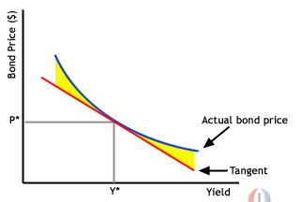

The degree to which the graph is curved shows how much a bond's yield changes in response to a change in price.

Properties of Convexity
Convexity is useful also for comparing bonds. If two bonds offer the same duration and yield but one exhibits greater convexity, changes in interest rates will affect each bond differently. A bond with greater convexity is less affected by interest rates than a bond with less convexity. Also, bonds with greater convexity will have a higher price than a bond with lower convexity, regardless of whether interest rates rise or fall. This relationship is illustrated in the following diagram:
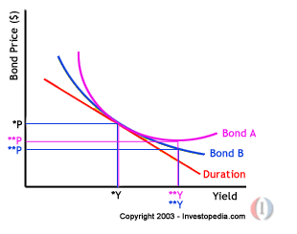
As you can see Bond A has greater convexity than Bond B, but they both have the same price and convexity when price equals *P and yield equals *Y. If interest rates changed from this point by a very small amount, then regardless of the convexity, both bonds would have approximately the same price. When yield increases by a large amount, however, the prices of both Bond A and Bond B decrease, but Bond B's price decreases more than Bond A's. Notice how at **Y the price of Bond A remains higher, demonstrating that investors will have to pay more money (accept a lower yield to maturity) for a bond with greater convexity

  - Immunization
Immunization is the structuring of a portfolio in such a way that any changes in the general level of interest rates will not negatively affect the total expected return from a bond or bond portfolio. There are some important assumptions underlying immunization through duration, chief among which are those when the general level of rates changes, all rates change in a parallel fashion, and that such changes will be "moderate". The latter assumption is necessary when convexity is not used, since duration is only accurate for relatively small changes around the status quo.
Immunization is an approach to interest-rate risk, not credit risk. It addresses the other two principal sources of risk in a bond portfolio: market risk and reinvestment risk. Briefly, the duration of a bond, or of a portfolio, measures exactly that investment horizon where market risk and reinvestment risk offset one another. Hence, it represents that time frame over which the currently available total return is assured.
  - Mortgage backed securities
A mortgage loan is a loan secured by the collateral of some specified real estate property, which obliges the borrower to make a predetermined series of payments. Financial products have been developed that use pools of mortgages as collateral for the issuance of a security. Such securities are called mortgage-backed securities. When a mortgage is used as collateral for the issuance of a security, the mortgage is securitized.

    - Participants in the mortgage market
- Mortgage originators
The original lender is called the mortgage originator. Mortgage originators include commercial banks, thrifts, mortgage bankers, life insurance companies etc. They typically charge a fee called the origination fee.
- Mortgage servicers
Mortgage loans involve collecting monthly payments and forwarding proceeds to owners of the loan, sending payment notices to mortgagers, reminding mortgagers when payments are overdue, maintaining records of principal balances etc.
- Mortgage insurers
The lenders may require borrowers to insure against default by the borrower. This is generally required by borrowers whose Loan-to-value (loan divided by the market value of the property) is greater than 80%.

    - Different types of mortgages
- Level payment, fixed-rate mortgages
The borrower pays the interest and repays the principal in equal instalments over an agreed-upon period of time, called the maturity or term of the mortgage. At the end of the term, the loan is fully amortized.
MP = MB [(I*[1+I]^n)/(1+I)^n – 1]

Where
MP = monthly mortgage payment
n = number of months
MB = Original mortgage balance
I = simple monthly interest rate (annual rate / 12)

- Adjustable-rate mortgages
The contract rate (interest rate) for the loans is reset periodically in accordance to a designated reference rate. The reference rates are either market determined (generally Treasury based rates) or based on cost of funds of the originators.
- Balloon mortgage
The borrower is given long term financing by the lender, but at specified future dates the contract rate is renegotiated. The balloon payment is the original amount borrowed less the amount amortized.
- “Two-step” mortgages
Akin to balloon mortgage, this has refinancing option for the borrower is fixed-rate mortgage with a single rate reset at some point prior to maturity. This rate reset occurs without specific action from the borrower.
- Graduated payment mortgage (GPM)
The interest rate and the term of the mortgage is fixed but the monthly mortgage payment is smaller in the initial years than for a level payment mortgage with the same contract rate but larger in the remaining years of the mortgage term.
- Growing equity mortgage (GEM)
This is a fixed rate mortgage whose monthly mortgage payments increase over time. The higher monthly mortgage payment is applied to paying off the principal. As a result, the principal of a GEM is repaid faster.
- Tiered-payment mortgage
Mortgage design with a fixed rate and a monthly payment that graduates over time but without negative amortization as in GPM.
- Fixed/Adjustable-rate mortgage hybrids
The mortgages have fixed rates for initial few years and then converted to floating rates with contractual characteristics similar to the adjustable rate mortgages.
  - Convertible bonds
Convertible securities are fixed income securities that permit the holder the right to exchange that security for the common stock of the issuing corporation under pre-specified conditions. The terms for the conversion is set forth in the security’s indenture. The option to convert is solely at the discretion of the bondholder.

Convertible bonds are often subordinated debentures, which mean the claims of “senior” creditors have to be fulfilled before the convertible bondholders in case of bankruptcy. The value of the convertible security is related to many variables including changes in the price of the underlying stock, changes in interest rates, credit quality and changes in the volatility of both the stock and the volatility of interest rates.

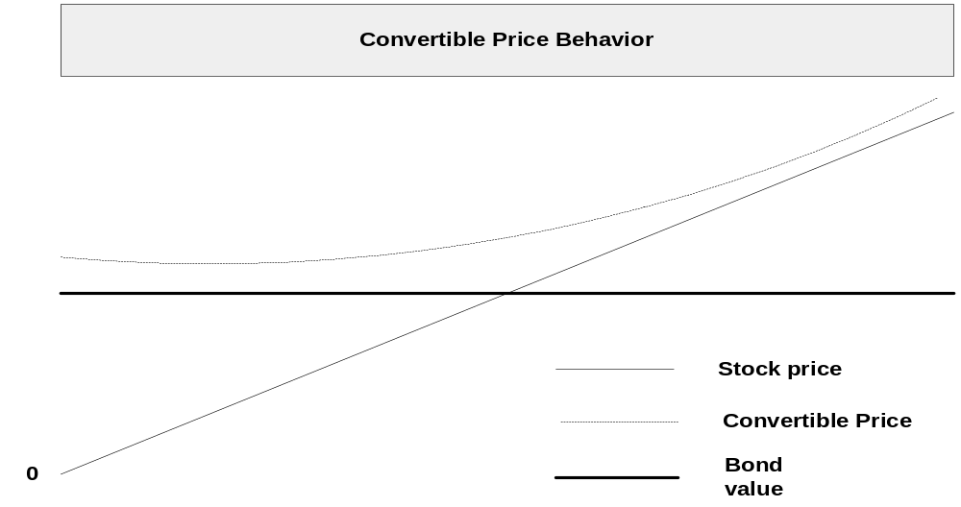

The yield on the convertible bond is lower than the yield on the more senior debt of the same issuer. The cumulative yield sacrificed represents a payment for the conversion privilege. The convertible bonds are historically issued with maturities of 25 to 30 years.

The value of a convertible bond disregarding the conversion feature is called straight value. This can be calculated by discounting the cash flow for the bond at a yield equal to the yield to maturity of an equivalent convertible bond. The value of the convertible bond if it is converted immediately into the common stock of the issuer is called its conversion value. The value is calculated by multiplying the conversion ratio with the price of the common stock. The minimum value of the convertible bond is the greater of its straight value and the conversion value.
  - Bonds with embedded options
Volatility of prices of securities is an important factor that money managers track and take a view on. Securities with embedded options to call the bonds is the feature using which the money manager can call the bond back and raise fresh capital at lower interest rates.
    - Callable bonds and Putable bonds
A callable security gives the issuer the right to redeem the security at a predetermined prices at specified times. In terms of value,

Callable bond value = Option less bond value – Call option value

The following diagram illustrates the value of a callable bond and option less bond with the change in interest rates
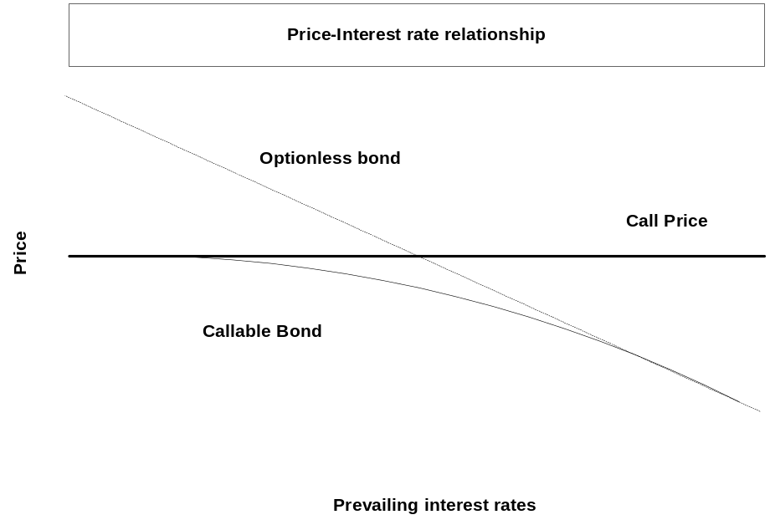

Typically, there is an initial period of call protection, after which the bond is callable at any time at a premium to par. The call price subsequently declines to par over the remaining life of the bond in a manner specified in the bond indenture.

The same logic applies to putable bonds; the holder has the right to sell the bond to the issuer at a designated time and price. A putable bond can likewise be broken into two separate parts and the value is,
Putable bond value = Option less bond value + Put option value

  - Forward pricing of bonds
    - Theoretical forward price based on arbitrage model
The forward price of a bond can be determined on the basis of the following information:
- The price of the bond in the cash market
- The coupon rate on the bond
- The interest rate for borrowing and lending until the settlement date. The borrowing and lending rate is referred to as the financing rate
Let us assume:
R = financing rate
C = current yield, or coupon rate divided by the cash market price
P = cash market price
F = forward price
T = time in years to the forward delivery date

Let us consider the following strategy:
Sell the forwards contract at F
Purchase the bond for P
Borrow P until the forward settlement date at R

The outcome on the settlement date is as follows:
From settlement of the forward contract
Flat price of bond F
Accrued interest +CTP
Total proceeds F + CTP

From the loan
Repayment of principal of the loan P
Interest on loan + RTP
Total outlay P + RTP

The profit will equal
Profit = Total proceeds - Total outlay
Profit = F + CTP – (P + RTP)

At equilibrium to eliminate arbitrage profit,

Profit = 0 = F + CTP – (P + RTP)

F = P + PT*(R-C)

  - Bond futures
A futures contract is an agreement between a buyer (seller) and an established futures exchange or its clearinghouse in which the buyer (seller) agrees to take (make) delivery of a specific amount of a valued item at a specified price and designated time.
To illustrate how an interest rate future works, suppose that X buys a futures contact and Y sells a futures contract on an 8% five-year Treasury note for settlement one year from now. The agreed price for both X and Y is $100. This is the futures price. This means that one-year from now Y must deliver an 8% five-year Treasury note and will receive $100. X will take delivery of an 8% Treasury note and will pay $100. The profit or loss would be dependent on the price at which the 8% Treasury note is trading currently.
When an investor takes a position in a futures contract, the buyer must deposit a minimum dollar amount per contract as specified by the exchange. As the price of the futures fluctuates, the value of the investor’s equity in the position changes. At the close of each trading day, any market gain results in an increase in the investor’s equity and any loss results in a decrease. This is called marked to market. Should an investor’s equity position fall below a certain amount determined by the exchange, the investor must pay additional margin. On the contrary, if the equity increases due to favourable changes in the market then the investor will be allowed to withdraw funds.
Interest rate futures contracts can be classified by the maturity of their underlying security. Short-term interest rate futures contracts have an underlying security that matures in less than one year. The maturity of the long-term futures contracts is more than one year.
The following are different types of futures contracts:
- The Treasury bond futures contract
- Treasury note futures
- Treasury bill futures contract
- Eurodollar time deposit futures contract

    - Applications to portfolio management
- Changing the duration of the portfolio
Money managers that have strong expectations about the direction of interest rates will adjust the duration of their portfolio to capitalize on their expectations. Specifically, if they expect interest rates to increase, they will shorten the duration of the portfolio and vice versa.
Money managers may use futures contracts by buying contracts on Treasury bonds or notes to increase the duration or sell T-Note contracts to shorten the duration.
- Asset allocation
An individual bond fund or balanced fund may use interest rate futures or stock index futures to balance between stocks and bonds.
- Creating synthetic securities for yield enhancements
Using a position in the futures contract together with the deliverable instrument one can synthetically create a cash market security. The yield on the synthetic security should be the same as the yield on the cash market security. If there is difference between the two yields, it can be exploited so as to enhance the yield on the portfolio.
For example, an investor who owns a 20-year T-Bond and sells Treasury futures that call for the delivery of that particular bond three months from now. The maturity of the T-Bond is 20 years, but the investor has effectively shortened the maturity to three months.
- Hedging
Hedging with futures involves taking a futures position as a temporary substitute for transactions to be made in the cash market at a later date. If cash and futures price move together, any loss realized by the hedger from one position will be offset by a profit on the other position.
  - Bond options
An option is a contract in which the seller of the option grants the buyer of the option the right to purchase from, or sell to, the seller a designation instrument at a specified time within a specified period of time. The seller gives this right to the buyer in exchange for a certain sum of money, called the option premium.
Consider, for example, an option on an 8% five-year Treasury note with one year to expiration and an exercise price of $100. Suppose that the option premium is $2 and the current price of the Treasury note is $100 with a yield of 8%. If the option is a call option, then the buyer of the option has the right to purchase an 8% five-year Treasury note for $100 within one year. Suppose the interest rate on the Treasury note falls and the price rises to $110 then the buyer can exercise the call option and realize a profit of (110 –100 – 2) = $8. Instead if the interest rates had risen and the price of the note had fallen to $90, then the buyer will not exercise the option to purchase the T-Note at $100. So the buyer would lose the Option premium of $2.
  - Bond options on futures
Like options on cash fixed income securities, both put and call options are traded on fixed income futures. The buyer of a call has the option of buying the underlying futures contract for a specified price. The buyer of a put has the option of selling the underlying futures contract for a specified price. An investor acquiring a position in futures does so at the current futures price. However, if the strike price on the option does not equal the futures price at the time of exercise, the option seller must compensate the options buyer for the discrepancy. Thus, when a call option is exercised the sell of the call must pay the buyer the current futures price minus the strike price.
The following are some of the important options on futures:
- Options on Treasury bond futures
- Options on Eurodollar futures
There are no margin requirements for the buyer of futures options, but the option price must be paid in full when the option is purchased. Because the option price is the maximum amount that the buyer can lose regardless of how adverse the price movement of the underlying futures contract, there is no need for margin.
  - Duration of bond futures
Duration of a bond that provides a cash flow C_{i} at a time Ti is:
n
Σ [T_{i} X [C_{i} e^ (-y T_{i})/B]
I =1

Where B is its price and y is it yield

But the conventional form of duration calculation of bond cannot be used for bond futures, as the futures do not give steady cash flows. To calculate the interest rate risk of an interest rate future, the common method is to adjust the basis point value of the bond in cash market by its conversion factor. The conversion factor can be viewed as the link between each deliverable bond and the futures market such that when a bond is delivered the invoice price is equal to:
(Futures price * conversion factor) + accrued interest. By this approach the interest rate risk of the underlying bond can be captured and then converted to a futures based measure of risk. The futures risk will changes as the risk of the underlying bond changes.

Duration based hedge-ratio is as follows:

PD_{p} / F_{c}D_{F}

F_{c}: Contract price for interest rate futures

D_{F}: Duration of asset underlying futures at maturity

P: Value of portfolio being hedged

D_{p}: Duration of portfolio at hedge maturity
  - Interest rate swaps
An interest rate swap is an agreement whereby two parties agree to exchange periodic interest payments. The amount to be exchanged is based on a predetermined dollar amount called the notional principal amount. The dollar amount to be paid by the two parties is the periodic interest rate multiplied by the notional principal amount.
The most common type of swap is where one party agrees to pay the other party fixed interest payments at designated dates for the life of the contract. This party is referred to as the fixed-rate payer. The other party agrees to make interest rate payments that float with some index and is referred to as the floating-rate payer.
The swap positions can be interpreted in two ways:
- A package of forward/futures contracts
- A package of cash flows from buying and selling cash market instruments
The following is a typical cash flow for a swap transaction:
Transaction: Party 1 takes a $50 million five-year floating-rate bond (LIBOR based), semi-annual payments loan from Party 2. Party 2 takes a $50 million for five years at fixed rate of 10%; semi-annual payments loan from Party 1.
The first column represents each six-month period at the end of which the coupon payments are due. The second column represents the cash flow w.r.t the Party 1 where he services the floating rate bond and receives the coupons for the fixed rate bond loaned to Party 2. The last column represents the Net cash flow for Party 1 combined the incoming and outgoing cash flows.

 | Cash flow in millions of dollars
Six-Month period | Floating rate bond | Fixed rate bond | Net
0 | (-)$50 | $50 | $0
1 | (LIBOR₁ / 2) x 50 | (-) 2.5 | (LIBOR₁ / 2) x 50 - 2.5
2 | (LIBOR2 / 2) x 50 | (-) 2.5 | (LIBOR₂ / 2) x 50 - 2.5
3 | (LIBOR3 / 2) x 50 | (-) 2.5 | (LIBOR₃ / 2) x 50 - 2.5
4 | (LIBOR4 / 2) x 50 | (-) 2.5 | (LIBOR₄ / 2) x 50 - 2.5
5 | (LIBOR5 / 2) x 50 | (-) 2.5 | (LIBOR₅ / 2) x 50 - 2.5
6 | (LIBOR6 / 2) x 50 | (-) 2.5 | (LIBOR₆ / 2) x 50 - 2.5
7 | (LIBOR7 / 2) x 50 | (-) 2.5 | (LIBOR₇ / 2) x 50 - 2.5
8 | (LIBOR8 / 2) x 50 | (-) 2.5 | (LIBOR₈ / 2) x 50 - 2.5
9 | (LIBOR9 / 2) x 50 | (-) 2.5 | (LIBOR₉ / 2) x 50 - 2.5
10 | (LIBOR₁₀ / 2) x 50 + 50 | (-) 52.5 | (LIBOR₁₀ / 2) x 50 - 2.5

Note: Dollar duration of a swap = Dollar duration of a fixed rate bond – Dollar duration of a floating rate bond
    - Applications of interest rate swaps
The following are the different situations where interest rates swaps are used in asset/liability management:
- Converting floating rate debt to fixed rate debt using swaps
Fixed-rate payer/floating rate receiver swaps can be used to convert floating rate liabilities to fixed rate liabilities because the floating rate receipts associated with the swap counterbalance the floating cost of liabilities. Any increase or decrease in liability costs is matched by a similar change in the floating rate inflows as long as the notional amount of the swap is equal to the principal amount.
- Converting fixed rate debt to floating rate debt using reverse swaps
A strategy similar to the above mentioned using reverse swaps, where financial institutions receive fixed rate cash flows and pays floating rate cash flows, is used to convert the fixed cost of liabilities to a synthetic floating rate. In this case, the fixed ate interest cost of liability is offset by the fixed rate inflow of the swap. Generally, financial institutions that have fixed rate debt and preponderance of floating rate assets such as adjustable rate mortgages, collateralised mortgages obligations (CMO) floater bonds, may adopt this strategy to better match the average duration of their assets and liabilities.

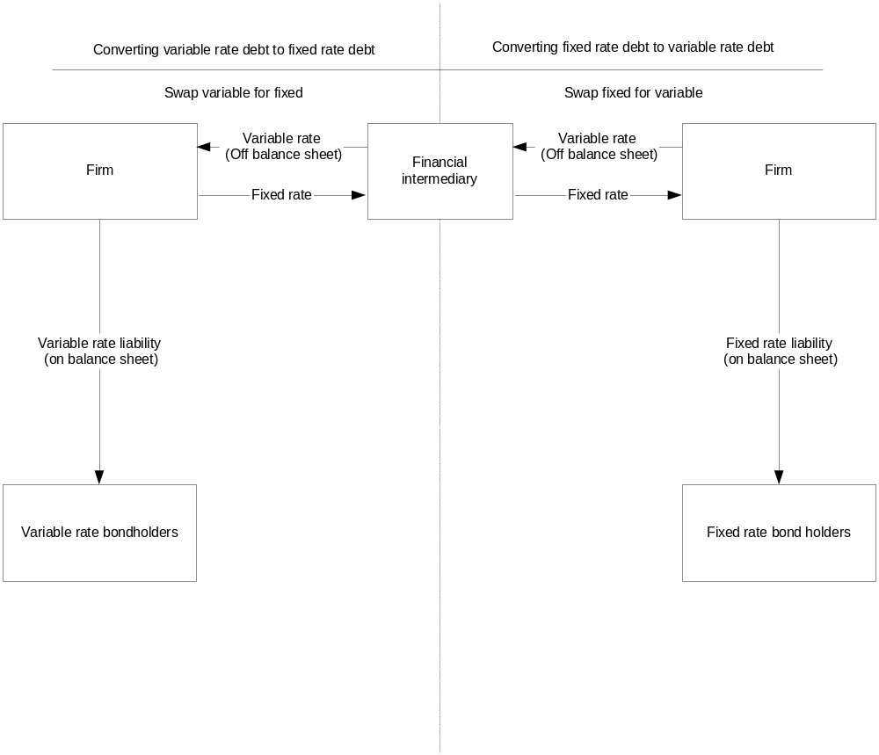
    - Termination of interest rate swaps
There are two ways to terminate a swap:
- Reverse swap
The simplest way to terminate an interest rate swap is to enter into an offsetting position. This can be done by matching the reset and settlement periods of the reverse swap to those of the original swap, the floating rate payment of the reverse swap is counterbalanced by the floating rate inflow from the original swap.
- Swap sale
In the above case the cash flows of two swaps and the credit risk of two counter parties need to be managed, which could be a problem. Instead, the firm may sell the swap for either a profit or loss in the secondary market. In the event that the current market swaps with a maturity equal to the remaining maturity of the swap to be terminated are being offered at a high fixed rate, the swap could be sold for a fee. On the other hand, if the current market swap is offered at a lower rate, an exit fee may be paid for terminating the swap. The termination value is determined as the present value of an annuity discounted for the remaining term to maturity at the current swap rate.
  - Exotic swaps
- Basis swaps
Basic swaps are designed to manage the basis risk inherent in a balance sheet where the asset returns and liability costs are based on different indexes.
- Yield-curve swaps
In yield curve swaps, the counter parties agree to exchange payments based on the difference between interest rates at two points on a given yield curve. These swaps are therefore an example of a floating rate for floating rate swap or basis swap.
- Amortizing and accreting swaps
In the previous cases, the notional amount for the swap does not change over the life of the swap. However, with respect to amortizing assets such as mortgage loans and other mortgage-backed instruments such as CMO bonds, the spread over funding costs will not be maintained as the asset principal balance declines over time. This is more critical for assets whose average life and duration may exhibit dramatic changes due to the possibility of prepayments. These cases a swap with constant notional amount would result in over hedging or under hedging. In it is these instances the institutions may enter into amortizing swap, which permits the notional amount of the swap and hence the exchange of cash flows to change at the amortization of the asset.
In case where the liability schedule is expected to increase an interest rate swap with an accreting balance may be used to fix the interest cost of the liabilities.
- Forward swaps
A forward swap allows a market participant to initiate a swap with a specified delayed start. Such swaps can be used to hedge debt re-financings or anticipated debt issuances in conjunction with expenditures expected in the future. For instance, suppose a firm has $200 million of non-callable fixed rate debt maturing in three years. The firm can get into a forward swap with current interest rate for 5 years to pay fixed and receive floating rate cash flows starting three years from now.
- Equity swaps
In an equity swap, the cash flows that are swapped are based on the total return on some stock market index and an interest rate (either fixed rate or floating rate). For example, a money manager can enter into two-year quarterly reset equity swap based on London FTSE versus LIBOR in which the manager receives the market index in pounds and pays the floating rate in pounds.
- Swaptions
Swaptions are typically options to pay or receive a predetermined fixed rate in exchange for LIBOR at some time in the future.
- Asset swaps
The earlier applications of swaps focussed exclusively on the use of interest rate swaps to liability based swaps. Asset based swaps, which use principles similar to the liability based swaps, are used to customize asset coupons and maturities. Asset swaps serve several functions; such as facilitating yield enhancement, creating assets that are not available in the marketplace, and changing the interest rate sensitivity of the portfolio, without trading the securities.
  - Caps, floors, collars
A floater is a debt security whose coupon rate is reset at designated dates based on the value of some designated reference rate. The coupon formula for a pure floater is represented as follows:
Coupon rate = reference rate (+ or -) quoted margin
The quoted margin is the adjustment that the issuer agrees to make to the reference rate.
A floater often imposes limits on how much the coupon rate can float. Specifically, a floater may have a restriction on the maximum coupon rate that will be paid on any reset date. This is called a cap. For example, a floater whose coupon formula is three month LIBOR plus 50 basis points with a cap of 7.5%. If the three-month LIBOR at a coupon-reset date were 8% then the coupon formulae would suggest the coupon rate to be 8.5%. However, the cap restricts the maximum coupon rate to 7.5%.
In contrast, a floater may also specify a minimum coupon rate called a floor. For example, an issue with quarterly coupon payments with coupon rate of 3-month LIBOR plus 25 basis points with a floor of 4.5%. If the three-month LIBOR ever fell below 4.25% then the coupon rate will remain at 4.5% for the investor.
When a floater possesses both a cap and a floor, this feature is referred to as a collar. Thus collared floater has both a maximum and a minimum value.
While a floaters’ coupon rate moves in the same direction as the reference rate, the floaters whose reference rates move in the opposite direction to the reference rates are called inverse floaters or reverse floaters.

  - OTC interest rate options
    - Structure of the OTC fixed income market
As in other OTC markets, the OTC fixed income market does not have a central marketplace for options and forwards. A transaction takes place whenever a buyer and seller agree to a price. Unlike an exchange transaction the terms, size, price etc of the transaction is not disclosed to other market participants. There is no clearing corporation that is part of OTC market; hence it is critical for the buyers and sellers to analyze the creditworthiness of their counter party.

Two major participant groups in the OTC markets are:
- Market makers
Market makers, typically large investment banks or commercial banks, stands ready to buy or sell a given option or a forward contract to accommodate client’s needs.
- Brokers
Brokers bring together buyers and seller, which could be market makers or other end users of the contract

The following are the major OTC contracts:
- Option on Mortgages
The Standby commitments were the first fixed income instrument offered on OTC option markets. Standbys are put options on mortgages that allow the mortgage holder to sell the mortgages at a given price during a given period of time. Today large investment banks, commercial banks offer options on mortgage creating a liquid market for trading these options. Mortgage bankers buy puts on the mortgages and thrift institutions sell both puts and calls. The majority of the mortgages traded are 30-year mortgages followed by 15-year mortgages. The expiration of the option contracts tend to be over short term of around 60 days.
- Option on treasury securities
Investment banks and commercial banks are the market makers standing ready to buy or sell options on the $100 million or more of Treasury securities. Most of the action is in options expiring within 60 days, written at the money or out of the money.
- Caps and floors on LIBOR
A cap on LIOB is a series of puts on LIBOR-based debt, whereas the floor on LIBOR is a series of calls on LIBOR-based debt.
Consider a five-year, $100 million cap on the three-month LIBOR struck at 11%. Such a contract will specify reset dates occurring every 3 months for a total of 20 resets. To determine the payoff at each reset date, one compares the 3-month LIBOR rate with 11% strike from a predetermined source. If the three-month LIBOR is at or below 11% then the seller owes nothing to the buyer. However, if the rate is above 11% then the cap seller must pay the cap buyer the monetary value of the amount by which the three-month LIBOR exceeds 11 %. In this case the 90-day interest accrual period, the value of each basis point is (.0001 x $100,000,000 x 90/360). Thus, for the above example if the three-month LIBOR is currently at 11.50% then the seller should pay $2500 x 50 = $125,000. The seller will pay the difference at each reset rate if the three-month LIBOR is greater than 11%.
For a floor, the seller will pay the buyer if the LIBOR rate is lesser that the floor rate. For example, if the buyer buys a $24 million seven-year 6.50% floor on six-month LIBOR, there are 14 reset dates. On each of these reset date, one compares the six-moth LIBOR rate with the floor rate. If the LIBOR rate is lower than 6.50% then the seller will pay the monetary value of the difference in rates as explained earlier.
- Forward rate agreements
Forward rate agreements market represents the over the counter equivalent of the exchange traded futures contract on short term rates. Any credit worthy individual can buy or sell FRAs. The liquid and easily accessible sector within FRA is for the three and six month LIBOR. Rates are widely quoted for settlement starting one month forward, and settling once every month thereafter out to 6 months forward. E.g. a FRA for a three-month LIBOR for a period starting one month and ending 4 months is referred to as 1 X 4 contracts. At the same time contracts with different starting and ending periods will also be available. Unlike futures market, new contracts with new settlement date are offered at the beginning of each given day. Commercial banks are the major market makers in the FRA market.

To determine the cash flow on settlement date, LIBOR rate specified in the FRA is compared to the LIBOR rate quoted at a pre-determined source. The actual dollar amount that changes hands is the difference the two rates, present valued for a period equal to the maturity of the underlying LIBOR (either 3 or 6 months). The rational behind the present valuing is that if an FRA is used to hedge the rate on a deposit the loss (gain) due to change in interest rate will be paid (saved) at the maturity of the deposit, not at the issue date.
Note: If one buys a FRA, one profits from an increase in rates and if one sells an FRA, one profits from a decline in rates

APPENDIX : BLACK SCHOLES PRICING EXAMPLES

Numerical examples:
Pricing call options using the Black Scholes model:
If the Coca Cola stock is trading at $164, calculate the price of an European call option on the stock with strike price 165 and time to maturity 35 days.
You are also provided with the following information:
The TBill rate is 5.35% (This rate is not continuously compounded).
The annual variance of the continuously compounded return on the stock price is 0.0841.
Use continuous compounding for the above calculations.
Here,
S = 164, E = 165, T = 35/365 = 0.09589
.r = ln(1.0535) = 0.052118, Vol = 0.29
C = S.N(d1) – E.e^(-rT).N(d2)
Where,
.d1 = [ln(S/E)+(r+{(vol)^2}/2).T]/(vol).(sqrt(T))
.d2 = d1 – (vol).(sqrt(T))
.ln(S/E) = ln(164/165) = -0.00608
(vol)^2 = 0.29^2 = 0.0841
{(vol)^2}/2 = 0.0841/2 = 0.04205
(r+{(vol)^2}/2) = 0.052118 + 0.04205 = 0.094168
(r+{(vol)^2}/2).T = (0.094168).(0.09589) = 0.00903
[ln(S/E)+(r+{(vol)^2}/2).T] = -0.00608 + 0.00903 = 0.002951
(sqrt(T)) = 0.309661
(vol).(sqrt(T)) = (0.29).(0.309661) = 0.089802
.d1 = 0.002951/0.089802 = 0.032858
.d2 = 0.032858 – 0.089802 = -0.05694
N(d1) = 0.513106
N(d2) = 0.477295
.e^(-rT) = e^(-0.005) = 0.995015
C = 164(0.513106) – (165)(0.995015)(0.477295) = 84.14942 – 78.36108 = 5.788339
Thus the value of the call is 5.788339

Using the normal distribution table manually:
N(d1) = 1 – 0.5239 = 0.4761
C = 5.803
Thus the value of the call using the normal distribution table manually is 5.803

Numerical example:
Pricing put options using the Black Scholes model:
If the Coca Cola stock is trading at $164,
Calculate the price of an European put option on the stock with strike price 165 and time to maturity 45 days.
You are also provided with the following information:
The TBill rate is 6% (This rate is not continuously compounded).
The monthly variance of the continuously compounded return of the stock price is 0.0075
Use continuous compounding for the above calculations.
Here,
S = 164, E = 165, T = 45/365 = 0.123288
.r = ln(1.06) = 0.058269, Vol = sqrt((0.0075).(12)) = sqrt(0.09) = 0.3
P = E.e^(-rT).(1-N(d2)) – S.(1-N(d1))
.d1 = [ln(S/E)+(r+{(vol)^2}/2).T]/(vol).(sqrt(T))
.d2 = d1 – (vol).(sqrt(T))
.ln(S/E) = ln(164/165) = -0.00608
{(vol)^2}/2 = 0.09/2 = 0.045
r+{(vol)^2}/2 = 0.058269 + 0.045 = 0.103269
(r+{(vol)^2}/2).T = (0.103269).(0.123288) = 0.012732
[ln(S/E)+(r+{(vol)^2}/2).T] = -0.00608 + 0.012732 = 0.006653
(vol).(sqrt(T)) = (0.3)(sqrt(0.123288)) = 0.105337
.d1 = 0.006653/0.105337 = 0.063159
.d2 = 0.063159 – 0.105337 = -0.04218
N(d1) = 0.52518
1-N(d1) = 0.47482
N(d2) = 0.483178
1-N(d2) = 0.516822
.e^(-rT) = e^(-0.00718) = 0.992842
P = 165(0.992842)(0.516822) – 164(0.47482) = 84.66523 – 77.87048 = 6.7947
Thus the value of the put is 6.7947

Using the normal distribution table manually:
N(d1) = 0.5239
1-N(d1) = 0.4761
N(d2) = 1 – 0.516 = 0.484
1-N(d2) = 0.516
P = 6.4502
Thus the value of the put using the normal distribution table manually is 6.4502

